UNITED STATES
SECURITIES AND EXCHANGE COMMISSION
Washington, D.C. 20549

FORM 8-K

CURRENT REPORT
PURSUANT TO SECTION 13 OR 15(D) OF THE
SECURITIES EXCHANGE ACT OF 1934

Date of Report (Date of earliest event reported): August 10, 2026
TPG Mortgage Investment Trust, Inc.

(Exact name of registrant as specified in its charter)
Maryland |  |  | 001-35151 |  |  | 27-5254382
(State or other jurisdiction of incorporation) |  |  | (Commission File Number) |  |  | (IRS Employer Identification No.)

245 Park Avenue, 26th floor
New York, New York 10167
(Address of principal executive offices)

Registrant's telephone number, including area code: (212) 692-2000

Not Applicable
(Former Name or Address, if Changed Since Last Report)

Check the appropriate box below if the Form 8-K is intended to simultaneously satisfy the filing obligation of the registrant under any of the following provisions:
 |  |  | x |  |  | Written communications pursuant to Rule 425 under the Securities Act (17 CFR 230.425)
 |  |  | ☐ |  |  | Soliciting material pursuant to Rule 14a-12 under the Exchange Act (17 CFR 240.14a-12)
 |  |  | ☐ |  |  | Pre-commencement communications pursuant to Rule 14d-2(b) under the Exchange Act (17 CFR 240.14d-2(b))
 |  |  | ☐ |  |  | Pre-commencement communications pursuant to Rule 13e-4(c) under the Exchange Act (17 CFR 240.13e-4(c)
Securities registered pursuant to Section 12(b) of the Act:
Title of each class: |  |  |  |  |  | Trading Symbols: |  |  |  |  |  | Name of each exchange on which registered:
Common Stock, $0.01 par value per share |  |  |  |  |  | MITT |  |  |  |  |  | New York Stock Exchange |  |  | (NYSE)
8.25% Series A Cumulative Redeemable Preferred Stock |  |  |  |  |  | MITT PrA |  |  |  |  |  | New York Stock Exchange |  |  | (NYSE)
8.00% Series B Cumulative Redeemable Preferred Stock |  |  |  |  |  | MITT PrB |  |  |  |  |  | New York Stock Exchange |  |  | (NYSE)
8.000% Series C Fixed-to-Floating Rate Cumulative Redeemable Preferred Stock |  |  |  |  |  | MITT PrC |  |  |  |  |  | New York Stock Exchange |  |  | (NYSE)
9.500% Senior Notes due 2029 |  |  |  |  |  | MITN |  |  |  |  |  | New York Stock Exchange |  |  | (NYSE)
9.500% Senior Notes due 2029 |  |  |  |  |  | MITP |  |  |  |  |  | New York Stock Exchange |  |  | (NYSE)

Indicate by check mark whether the registrant is an emerging growth company as defined in Rule 405 of the Securities Act of 1933 (§230.405 of this chapter) or Rule 12b-2 of the Securities Exchange Act of 1934 (§240.12b-2 of this chapter).
Emerging growth company ☐
If an emerging growth company, indicate by check mark if the registrant has elected not to use the extended transition period for complying with any new or revised financial accounting standards provided pursuant to Section 13(a) of the Exchange Act. ☐

Item 2.02 Results of Operations and Financial Condition.

On August 10, 2026, TPG Mortgage Investment Trust, Inc. (the “Company”) issued a press release and an earnings presentation announcing its financial results for the fiscal quarter ended June 30, 2026.

Pursuant to the rules and regulations of the Securities and Exchange Commission, the press release and earnings presentation are attached to this Current Report on Form 8-K as Exhibits 99.1 and 99.2, respectively, and the information contained in such press release and earnings presentation are incorporated into this Item 2.02 by this reference. The information contained in this Item 2.02, including Exhibits 99.1 and 99.2, is being “furnished” and shall not be deemed “filed” for the purposes of Section 18 of the Securities Exchange Act of 1934, as amended (“Exchange Act”), or otherwise subject to the liabilities of that section, nor shall it be deemed to be incorporated by reference into any registration statement or other document pursuant to the Securities Act of 1933, as amended, or into any filing or other document pursuant to the Exchange Act, except as otherwise expressly stated in such filing.

Item 9.01 Financial Statements and Exhibits.

(d) Exhibits.
Exhibit No. |  |  |  |  |  | Description
99.1 |  |  |  |  |  | Press Release, dated August 10, 2026
99.2 |  |  |  |  |  | Earnings Presentation for the fiscal quarter ended June 30, 2026
104 |  |  |  |  |  | Cover Page Interactive Data File (formatted as Inline XBRL)

Important Additional Information and Where to Find It

In connection with the Company’s proposed acquisition of Cherry Hill Mortgage Investment Corporation (“CHMI”) by merger (“Merger”), the Company expects to file with the U.S. Securities and Exchange Commission (the “SEC”) a registration statement on Form S-4 (the “Registration Statement”) that will include a prospectus of the Company and a joint proxy statement of the Company and CHMI (the “joint proxy statement/prospectus”). The joint proxy statement/prospectus will contain important information about the Company, CHMI, the proposed Merger and related matters. The Company and CHMI also expect to file with the SEC other documents regarding the Merger. The Merger will be submitted to the stockholders of the Company and CHMI for their consideration. The definitive joint proxy statement/prospectus will be sent to the stockholders of the Company and CHMI, and will contain important information about the Company, CHMI, the proposed Merger and related matters. This communication is not a substitute for any proxy statement, registration statement, tender or exchange offer statement, prospectus or other document the Company or CHMI may file with the SEC in connection with the proposed Merger and related matters. INVESTORS AND SECURITY HOLDERS ARE ADVISED TO READ THE REGISTRATION STATEMENT ON FORM S-4 AND THE RELATED JOINT PROXY STATEMENT/PROSPECTUS (INCLUDING ALL AMENDMENTS AND SUPPLEMENTS THERETO) AND OTHER RELEVANT DOCUMENTS FILED BY the Company AND CHMI WITH THE SEC CAREFULLY AND IN THEIR ENTIRETY IF AND WHEN THEY BECOME AVAILABLE BECAUSE THEY WILL CONTAIN IMPORTANT INFORMATION ABOUT THE COMPANY, CHMI AND THE PROPOSED MERGER. Investors and security holders may obtain copies of these documents free of charge (if and when they become available) through the website maintained by the SEC at www.sec.gov. Copies of the documents filed by the Company with the SEC are also available free of charge on the Company’s website at www.mitt.tpg.com. Copies of the documents filed by CHMI with the SEC are also available free of charge on CHMI’s website at www.chmireit.com.

Participants in the Solicitation Relating to the Merger

The Company, CHMI and certain of their respective directors and executive officers and certain other affiliates of the Company and CHMI may be deemed to be participants in the solicitation of proxies from the common stockholders of CHMI and the Company in respect of the proposed Merger. Information regarding CHMI and its directors and executive officers and their ownership of common stock of CHMI can be found in CHMI’s Annual Report on Form 10-K for the fiscal year ended December 31, 2025, filed with the SEC on March 5, 2026, and in its definitive proxy statement relating to its 2026 annual meeting of stockholders, filed with the SEC on April 21, 2026. Information regarding the Company and its directors and executive officers and their ownership of common stock of the Company can be found in the Company’s Annual Report on Form 10-K for the fiscal year ended December 31, 2025, filed with the SEC on February 25, 2026, and in its definitive proxy statement relating to its 2026 annual meeting of stockholders, filed with the SEC on March 16, 2026. Additional information regarding the interests of such participants in the Merger will be included in the joint proxy statement/prospectus and other

relevant documents relating to the proposed Merger when they are filed with the SEC. These documents are available free of charge on the SEC’s website and from the Company or CHMI, as applicable, using the sources indicated above.

No Offer or Solicitation

This communication and the information contained herein shall not constitute an offer to sell or the solicitation of an offer to buy any securities, nor shall there be any sale of securities in any jurisdiction in which such offer, solicitation or sale would be unlawful prior to registration or qualification under the securities laws of any such jurisdiction. No offering of securities shall be made except by means of a prospectus meeting the requirements of Section 10 of the Securities Act of 1933, as amended (the “Securities Act”). This communication may be deemed to be solicitation material in respect of the proposed Merger.

Forward-Looking Statements

This communication includes "forward-looking statements" within the meaning of Section 27A of the Securities Act of 1933, as amended, and Section 21E of the Securities Exchange Act of 1934, as amended. The Company intends such statements to be covered by the safe harbor provisions for forward-looking statements contained in the Private Securities Litigation Reform Act of 1995 and includes this statement for purposes of complying with the safe harbor provisions. Words such as "expects," "endeavor," "anticipates," "intends," "plans," "believes," "seeks," "estimates," "will," "should," "may," "projects," "could," "estimates," "continue" or variations of such words and other similar expressions are intended to identify such forward-looking statements, which generally are not historical in nature, but not all forward-looking statements include such identifying words. Forward-looking statements are based on our beliefs, assumptions and expectations of our future operations, business strategies, performance, financial condition, liquidity and prospects, taking into account information currently available to us, and are not guarantees of future performance. Forward-looking statements regarding the Company include, but are not limited to, the Company’s leverage profile, the Company’s ability to consistently rotate capital into higher-returning residential investments, the ability to scale profitability at Arc Home, whether the Company’s earnings will continue to support its dividend, the Company’s dividend levels, whether the Company is well positioned to drive increased earnings power, statements related to the proposed Merger, including the anticipated timing, benefits and financial and operational impact thereof; other statements of management’s belief, intentions or goals; and other statements that are not historical facts. These forward-looking statements are subject to various risks and uncertainties. Accordingly, there are or will be important factors that could cause actual outcomes or results to differ materially from those indicated in these statements. The Company believes these factors include, without limitation, changes in general economic or market conditions, including changes in inflation, tariffs, interest rates and the fair value of our assets; changes in government regulations affecting our business; the Company’s ability to grow its residential loan portfolio; changes in prepayment rates and mortgage default rates on the Company’s assets; financing needs and arrangements; the Company’s and CHMI’s ability to complete the proposed Merger on the proposed terms or on the anticipated timeline, or at all, including risks and uncertainties related to securing the necessary stockholder approval from CHMI’s and the Company’s respective stockholders and satisfaction of other closing conditions to consummate the proposed Merger; the occurrence of any event, change or other circumstance that could give rise to the termination of the Merger Agreement; risks related to diverting the attention of the Company and CHMI management from ongoing business operations; failure to realize the expected benefits of the proposed Merger; significant transaction costs and/or unknown or inestimable liabilities; the risk of stockholder litigation in connection with the proposed Merger, including resulting expense or delay; the risk that the Company’s and CHMI’s respective businesses will not be integrated successfully or that such integration may be more difficult, time-consuming or costly than expected; and effects relating to the announcement of the proposed Merger or any further announcements or the consummation of the proposed Merger on the market price of the Company’s or CHMI’s common stock; and the risk factors contained in the Company’s filings with the Securities and Exchange Commission ("SEC"), including those described under the headings "Forward-Looking Statements" and "Risk Factors" in the Company’s Annual Report on Form 10-K for the fiscal year ended December 31, 2025 and in other reports and documents filed by the Company with the SEC from time to time, which are accessible on the SEC's website, http://www.sec.gov/. Moreover, other risks and uncertainties of which the Company is not currently aware may also affect the Company’s forward-looking statements and may cause actual results and the timing of events to differ materially from those anticipated. The forward-looking statements made in this communication are made only as of the date of this communication or as of the dates indicated in the forward-looking statements, even if they are subsequently made available by the Company on its website or otherwise. The Company undertakes no obligation to update or supplement any forward-looking statements to reflect actual results, new information, future events, changes in its expectations or other circumstances that exist after the date as of which the forward-looking statements were made, except as required by law. All financial information in this communication is as of June 30, 2026, unless otherwise indicated.

SIGNATURES

Pursuant to the requirements of the Securities Exchange Act of 1934, the registrant has duly caused this report to be signed on its behalf by the undersigned hereunto duly authorized.

Date: August 10, 2026 |  |  | TPG MORTGAGE INVESTMENT TRUST, INC.
 |  |  | By: |  |  | /s/ JENNY B. NESLIN
 |  |  |  |  |  | Name: Jenny B. Neslin
 |  |  |  |  |  | Title: General Counsel and Secretary

Exhibit 99.1

TPG Mortgage Investment Trust, Inc. Reports Second Quarter 2026 Results

NEW YORK, NY, August 10, 2026 / Business Wire - TPG Mortgage Investment Trust, Inc. ("MITT," "we," the "Company," or "our") (NYSE: MITT) today reported financial results for the quarter ended June 30, 2026.

MANAGEMENT REMARKS

"Despite a challenging interest rate environment, our disciplined leverage profile, consistent capital rotation into high-returning residential credit strategies, and strong momentum at Arc Home produced EAD of $0.24 per share for the second quarter, fully covering our dividend while increasing our book value to $10.00 per share," said T.J. Durkin, Chief Executive Officer and President. "Looking ahead, we believe our definitive agreement to acquire Cherry Hill Mortgage Investment Corporation will significantly enhance our scale and long-term earnings power by expanding our equity capital base, driving meaningful cost synergies, and incorporating complementary, durable cash flows. We are confident in our positioning and the compelling opportunities ahead to deliver for our shareholders.”

SECOND QUARTER FINANCIAL HIGHLIGHTS

•$10.00 Book Value per share as of June 30, 2026(1)
◦Quarterly economic return on equity of 2.7%(2)
•$0.29 of Net Income/(Loss) Available to Common Stockholders per diluted common share(3)
•$0.24 of Earnings Available for Distribution ("EAD") per diluted common share(3),(4)
•$0.24 dividend per common share declared in the second quarter of 2026

INVESTING AND FINANCING HIGHLIGHTS

•$7.7 billion Investment Portfolio as of June 30, 2026(5)
◦0.7% Net Interest Margin, which includes a 0.02% benefit from the net interest component of our interest rate swaps(6)
•$46.4 million investment in Arc Home as of June 30, 2026 determined using a valuation multiple of 1.05x book value(7)
•$7.3 billion of financing as of June 30, 2026(5)
◦$6.3 billion of non-recourse and $1.0 billion of recourse financing
◦13.4x GAAP Leverage Ratio and 1.8x Economic Leverage Ratio(8)
•$111.6 million of total liquidity as of June 30, 2026(9)

DIVIDENDS

•On June 16, 2026, declared a second quarter dividend of $0.24 per common share
•On July 30, 2026, declared quarterly cash dividends of $0.51563, $0.50, and $0.664786 per share on our Series A, Series B, and Series C Preferred Stock, respectively, payable on September 17, 2026 to preferred shareholders of record on August 31, 2026

STOCKHOLDER CALL

The Company invites stockholders, prospective stockholders, and analysts to participate in MITT’s second quarter earnings conference call on Monday, August 10, 2026 at 8:30 a.m. Eastern Time.

To participate in the call by telephone, please dial (800) 347-6865 at least five minutes prior to the start time. International callers should dial (203) 518-9757. The Conference ID is MITTQ226. To listen to the live webcast of the conference call, please go to https://event.on24.com/wcc/r/5416544/7D08A1214A9046837D90BDB16266BB09 and register using the same Conference ID.

The Company issued an earnings presentation detailing its second quarter 2026 financial results, which is available on the Company’s website, www.mitt.tpg.com, under "Presentations" in the "News & Presentations" section. Additional information
1
regarding the proposed acquisition by the Company of Cherry Hill Mortgage Investment Corporation by merger can be found in the joint press release issued today and in the investor presentation relating to the proposed acquisition, both of which are available on MITT’s website at www.mitt.tpg.com. The investor presentation is also being furnished by MITT in a Current Report on Form 8-K filed with the SEC on the date hereof.

For those unable to listen to the live call, an audio replay will be available on August 10, 2026 through 9:00 a.m. Eastern Time on September 10, 2026. To access the replay, please go to the Company’s website at www.mitt.tpg.com.

ABOUT TPG MORTGAGE INVESTMENT TRUST, INC.

TPG Mortgage Investment Trust, Inc. is a residential mortgage REIT with a focus on investing in a diversified risk-adjusted portfolio of residential mortgage-related assets in the U.S. mortgage market. The Company is externally managed and advised by AG REIT Management, LLC, an affiliate of TPG Inc. (NASDAQ: TPG).

Additional information can be found on the Company’s website at www.mitt.tpg.com.

Important Additional Information and Where to Find It

In connection with MITT’s proposed acquisition of Cherry Hill Mortgage Investment Corporation (“CHMI”) by merger (“Merger”), MITT expects to file with the U.S. Securities and Exchange Commission (the “SEC”) a registration statement on Form S-4 (the “Registration Statement”) that will include a prospectus of MITT and a joint proxy statement of MITT and CHMI (the “joint proxy statement/prospectus”). The joint proxy statement/prospectus will contain important information about MITT, CHMI, the proposed Merger and related matters. MITT and CHMI also expect to file with the SEC other documents regarding the Merger. The Merger will be submitted to the stockholders of CHMI for their consideration. Issuance of MITT stock in the Merger will be submitted to the stockholders of MITT for their consideration. The definitive joint proxy statement/prospectus will be sent to the stockholders of MITT and CHMI, and will contain important information about MITT, CHMI, the proposed Merger and related matters. This communication is not a substitute for any proxy statement, registration statement, tender or exchange offer statement, prospectus or other document MITT or CHMI may file with the SEC in connection with the proposed Merger and related matters. INVESTORS AND SECURITY HOLDERS ARE ADVISED TO READ THE REGISTRATION STATEMENT ON FORM S-4 AND THE RELATED JOINT PROXY STATEMENT/PROSPECTUS (INCLUDING ALL AMENDMENTS AND SUPPLEMENTS THERETO) AND OTHER RELEVANT DOCUMENTS FILED BY MITT AND CHMI WITH THE SEC CAREFULLY AND IN THEIR ENTIRETY IF AND WHEN THEY BECOME AVAILABLE BECAUSE THEY WILL CONTAIN IMPORTANT INFORMATION ABOUT MITT, CHMI AND THE PROPOSED MERGER. Investors and security holders may obtain copies of these documents free of charge (if and when they become available) through the website maintained by the SEC at www.sec.gov. Copies of the documents filed by MITT with the SEC are also available free of charge on MITT’s website at www.mitt.tpg.com. Copies of the documents filed by CHMI with the SEC are also available free of charge on CHMI’s website at www.chmireit.com.

Participants in the Solicitation Relating to the Merger

MITT, CHMI and certain of their respective directors and executive officers and certain other affiliates of MITT and CHMI may be deemed to be participants in the solicitation of proxies from the common stockholders of CHMI and MITT in respect of the proposed Merger. Information regarding CHMI and its directors and executive officers and their ownership of common stock of CHMI can be found in CHMI’s Annual Report on Form 10-K for the fiscal year ended December 31, 2025, filed with the SEC on March 5, 2026, and in its definitive proxy statement relating to its 2026 annual meeting of stockholders, filed with the SEC on April 21, 2026. Information regarding MITT and its directors and executive officers and their ownership of common stock of MITT can be found in MITT’s Annual Report on Form 10-K for the fiscal year ended December 31, 2025, filed with the SEC on February 25, 2026, and in its definitive proxy statement relating to its 2026 annual meeting of stockholders, filed with the SEC on March 16, 2026. Additional information regarding the interests of such participants in the Merger will be included in the joint proxy statement/prospectus and other relevant documents relating to the proposed Merger when they are filed with the SEC. These documents are available free of charge on the SEC’s website and from MITT or CHMI, as applicable, using the sources indicated above.

No Offer or Solicitation

This communication and the information contained herein shall not constitute an offer to sell or the solicitation of an offer to buy any securities, nor shall there be any sale of securities in any jurisdiction in which such offer, solicitation or sale would be unlawful prior to registration or qualification under the securities laws of any such jurisdiction. No offering of securities
2
shall be made except by means of a prospectus meeting the requirements of Section 10 of the Securities Act of 1933, as amended (the “Securities Act”). This communication may be deemed to be solicitation material in respect of the proposed Merger.

FORWARD LOOKING STATEMENTS

This press release includes "forward-looking statements" within the meaning of Section 27A of the Securities Act of 1933, as amended, and Section 21E of the Securities Exchange Act of 1934, as amended. The Company intends such statements to be covered by the safe harbor provisions for forward-looking statements contained in the Private Securities Litigation Reform Act of 1995 and includes this statement for purposes of complying with the safe harbor provisions. Words such as "expects," "endeavor," "anticipates," "intends," "plans," "believes," "seeks," "will," "should," "may," "projects," "could," "estimates," "continue" or variations of such words and other similar expressions are intended to identify such forward-looking statements, which generally are not historical in nature, but not all forward-looking statements include such identifying words. Forward-looking statements are based on our beliefs, assumptions and expectations of our future operations, business strategies, performance, financial condition, liquidity and prospects, taking into account information currently available to us, and are not guarantees of future performance. Forward-looking statements regarding the Company include, but are not limited to, the Company’s leverage profile, the Company’s ability to consistently rotate capital into higher-returning residential investments, whether momentum at Arc Home will continue, whether the Company’s earnings will continue to support its dividend, the Company’s dividend levels, whether the Company is well positioned to drive increased earnings power, statements related to the proposed Merger, including the anticipated timing, benefits and financial and operational impact thereof, other statements of management’s belief, intentions or goals, and other statements that are not historical facts. These forward-looking statements are subject to various risks and uncertainties. Accordingly, there are or will be important factors that could cause actual outcomes or results to differ materially from those indicated in these statements. The Company believes these factors include, without limitation, changes in general economic or market conditions, including changes in inflation, tariffs, interest rates and the fair value of our assets; changes in government regulations affecting our business; the Company’s ability to grow its residential loan portfolio; changes in prepayment rates and mortgage default rates on the Company’s assets; financing needs and arrangements; MITT’s and CHMI’s ability to complete the proposed Merger on the proposed terms or on the anticipated timeline, or at all, including risks and uncertainties related to securing the necessary stockholder approval from CHMI’s and MITT’s respective stockholders and satisfaction of other closing conditions to consummate the proposed Merger; the occurrence of any event, change or other circumstance that could give rise to the termination of the Merger Agreement; risks related to diverting the attention of MITT and CHMI management from ongoing business operations; failure to realize the expected benefits of the proposed Merger; significant transaction costs and/or unknown or inestimable liabilities; the risk of stockholder litigation in connection with the proposed Merger, including resulting expense or delay; the risk that MITT’s and CHMI’s respective businesses will not be integrated successfully or that such integration may be more difficult, time-consuming or costly than expected; and effects relating to the announcement of the proposed Merger or any further announcements or the consummation of the proposed Merger on the market price of MITT’s or CHMI’s common stock; and the risk factors contained in the Company’s filings with the Securities and Exchange Commission ("SEC"), including those described under the headings "Forward-Looking Statements" and "Risk Factors" in the Company’s Annual Report on Form 10-K for the fiscal year ended December 31, 2025 and in other reports and documents filed by the Company with the SEC from time to time, which are accessible on the SEC's website, http://www.sec.gov/. Moreover, other risks and uncertainties of which the Company is not currently aware may also affect the Company’s forward-looking statements and may cause actual results and the timing of events to differ materially from those anticipated. The forward-looking statements made in this press release are made only as of the date of this press release or as of the dates indicated in the forward-looking statements, even if they are subsequently made available by the Company on its website or otherwise. The Company undertakes no obligation to update or supplement any forward-looking statements to reflect actual results, new information, future events, changes in its expectations or other circumstances that exist after the date as of which the forward-looking statements were made, except as required by law. All financial information in this press release is as of June 30, 2026, unless otherwise indicated.

NON-GAAP FINANCIAL MEASURES

This press release contains EAD and Economic Leverage Ratio, non-GAAP financial measures. Our presentation of these measures may not be comparable to similarly-titled measures of other companies, who may use different calculations. These non-GAAP measures should not be considered a substitute for, or superior to, the financial measures calculated in accordance with GAAP. Our GAAP financial results and the reconciliations from these results included herein should be carefully evaluated.

3
NON-GAAP FINANCIAL MEASURES

Earnings Available for Distribution(4)

A reconciliation of GAAP Net Income/(loss) available to common stockholders to EAD is set forth below (in thousands, except per share data).
 |  |  | Three Months Ended June 30, 2026
 |  |  | Amount |  |  |  |  |  | Per Diluted Share(3)
Net Income/(loss) available to common stockholders |  |  | $ | 9,092 |  |  |  |  | $ | 0.29
Add (Deduct):
Net realized (gain)/loss |  |  | 1,844 |  |  |  |  |  | 0.06
Net unrealized (gain)/loss |  |  | (4,422) |  |  |  |  |  | (0.15)
Transaction related expenses(a) |  |  | 210 |  |  |  |  |  | 0.01
Equity in (earnings)/loss from affiliates |  |  | (269) |  |  |  |  |  | (0.01)
EAD from equity method investments(b),(c),(d) |  |  | 1,281 |  |  |  |  |  | 0.04
Earnings available for distribution |  |  | $ | 7,736 |  |  |  |  | $ | 0.24
(a) The following table presents additional detail related to transaction related expenses excluded from EAD (in thousands). The interest expense line item relates to the amortization of deferred financing costs and the income tax expense line item relates to taxes incurred on items excluded from EAD.
Consolidated statements of operations line item: |  |  | Three Months Ended June 30, 2026
Transaction related expenses |  |  | $ | 92
Interest expense |  |  | 84
Income tax expense |  |  | 34
Transaction related expenses |  |  | $ | 210
(b) For the three months ended June 30, 2026, $(0.2) million of realized and unrealized changes in the fair value of Arc Home's mortgage servicing rights, transaction related expenses, and other asset impairments, net of related tax expense or benefit, were excluded from EAD.
(c) For the three months ended June 30, 2026, $(0.3) million of unrealized changes in the fair value of our investment in Arc Home were excluded from EAD.
(d) EAD recognized by AG Arc does not include our portion of gains recorded by Arc Home in connection with the sale of residential mortgage loans to us. There were no intra-entity profits in connection with the sale of residential mortgage loans to us recognized by Arc Home during the three months ended June 30, 2026.

Economic Leverage Ratio(8)

The calculation in the table below divides GAAP Leverage and Economic Leverage by our GAAP stockholders’ equity to derive our leverage ratios. The following table presents a reconciliation of our GAAP Leverage ratio to our Economic Leverage ratio ($ in thousands).

June 30, 2026 |  |  |  |  |  | Leverage |  |  |  |  |  | Stockholders’ Equity |  |  |  |  |  | Leverage Ratio
Securitized debt, at fair value(a) |  |  |  |  |  | $ | 6,355,237
Financing arrangements(b) |  |  |  |  |  | 891,015
Senior unsecured notes(b) |  |  |  |  |  | 96,858
Restricted cash posted on Financing arrangements |  |  |  |  |  | (8,030)
GAAP Leverage |  |  |  |  |  | $ | 7,335,080 |  |  |  |  | $ | 546,004 |  |  |  |  | 13.4x
Non-recourse financing arrangements(a) |  |  |  |  |  | (6,355,237)
Economic Leverage |  |  |  |  |  | $ | 979,843 |  |  |  |  | $ | 546,004 |  |  |  |  | 1.8x
(a) Securitized debt, at fair value is non-recourse to us.
(b) Financing arrangements and senior unsecured notes are recourse to us.
4

Footnotes
(1) Book value is calculated using stockholders’ equity less the liquidation preference of our cumulative redeemable preferred stock of $228.0 million.
(2) The economic return on equity represents the change in book value per share during the period, plus the common dividends per share declared over the period, divided by book value per share from the prior period.
(3) Diluted per share figures are calculated using diluted weighted average outstanding shares in accordance with GAAP.
(4) We define EAD, a non-GAAP financial measure, as Net Income/(loss) available to common stockholders excluding (i) (a) unrealized gains/(losses) on loans, real estate securities, derivatives and other investments, inclusive of our investment in AG Arc and Arc Home's net mortgage servicing rights, and (b) net realized gains/(losses) on the sale or termination of such instruments, (ii) any transaction related expenses incurred in connection with the acquisition, disposition, or securitization of our investments, (iii) the income tax effect on non-EAD income/(loss) items, and (iv) certain other nonrecurring gains or losses. Items (i) through (iv) above include any amount related to those items held in affiliated entities. EAD includes the net interest income and other income earned on our investments on a yield adjusted basis, including the net interest component of interest rate swaps, TBA dollar roll income/(loss), or any other investment activity that may earn or pay net interest or its economic equivalent. Additionally, EAD includes the net operating income/(loss) from Arc Home. Transaction related expenses are primarily comprised of costs incurred prior to or at the time of executing our securitizations and acquiring or disposing of residential mortgage loans. These costs are nonrecurring and may include underwriting fees, legal fees, diligence fees, and other similar transaction related expenses. Recurring expenses, such as servicing fees, custodial fees, trustee fees and other similar ongoing fees are not excluded from earnings available for distribution. Management considers the transaction related expenses and income taxes related to non-EAD income/(loss) items to be similar to realized losses incurred at the acquisition, disposition, or securitization of an asset and does not view them as being part of its core operations.
(5) The Investment Portfolio consists of Residential Investments, Agency RMBS, and Legacy WMC Commercial Investments, all of which are held at fair value. Financing is inclusive of Securitized Debt, which is held at fair value, Financing Arrangements, and Senior Unsecured Notes. This press release excludes investments held through AG Arc LLC unless otherwise noted.
(6) Net interest margin is calculated by subtracting the weighted average cost of funds on our financing from the weighted average yield for our Investment Portfolio, which excludes cash held.
(7) We invest in Arc Home LLC, a licensed mortgage originator, through AG Arc LLC, one of our equity method investees. Our investment in AG Arc LLC represents a 66% ownership interest as of June 30, 2026.
(8) We define GAAP Leverage as the sum of (1) Securitized debt, at fair value, (2) Financing arrangements, net of any restricted cash posted on such financing arrangements, (3) Senior Unsecured Notes, and (4) the amount payable on purchases that have not yet settled less the financing remaining on sales that have not yet settled. We define Economic Leverage, a non-GAAP financial measure, as the sum of our GAAP Leverage, exclusive of any fully non-recourse financing arrangements, and our net TBA position (at cost), if any. Our leverage does not include any financing utilized through AG Arc.
(9) Total liquidity includes $61.6 million of cash and cash equivalents and $50.0 million of available committed financing on certain Home Equity Loans. As of June 30, 2026, we pledged Home Equity Loans with a fair value of $63.5 million in which we have no outstanding financing but have $50 million of available financing which is contractually committed.

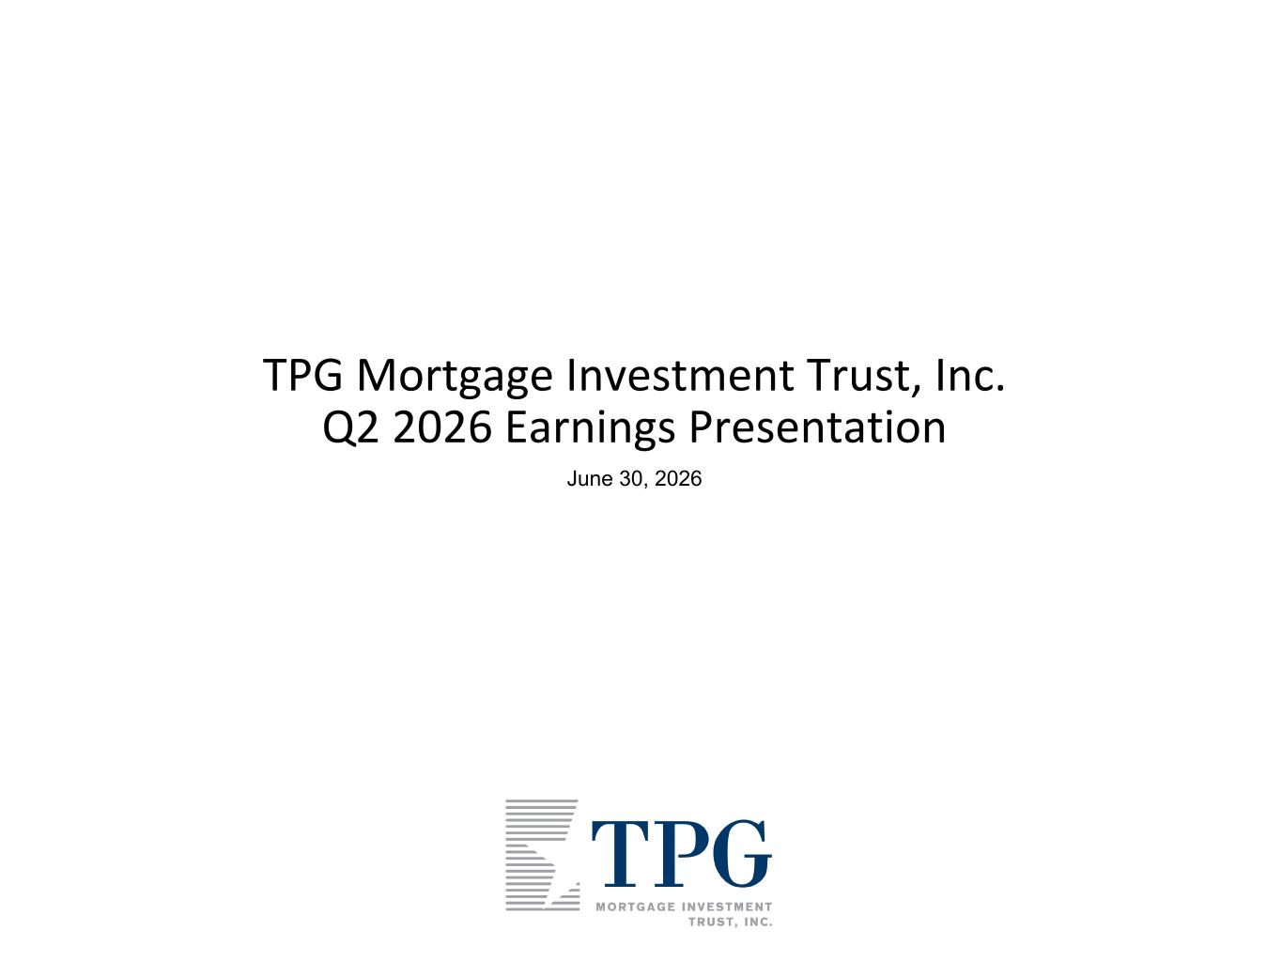
5
1 TPG Mortgage Investment Trust, Inc. Q2 2026 Earnings Presentation June 30, 2026

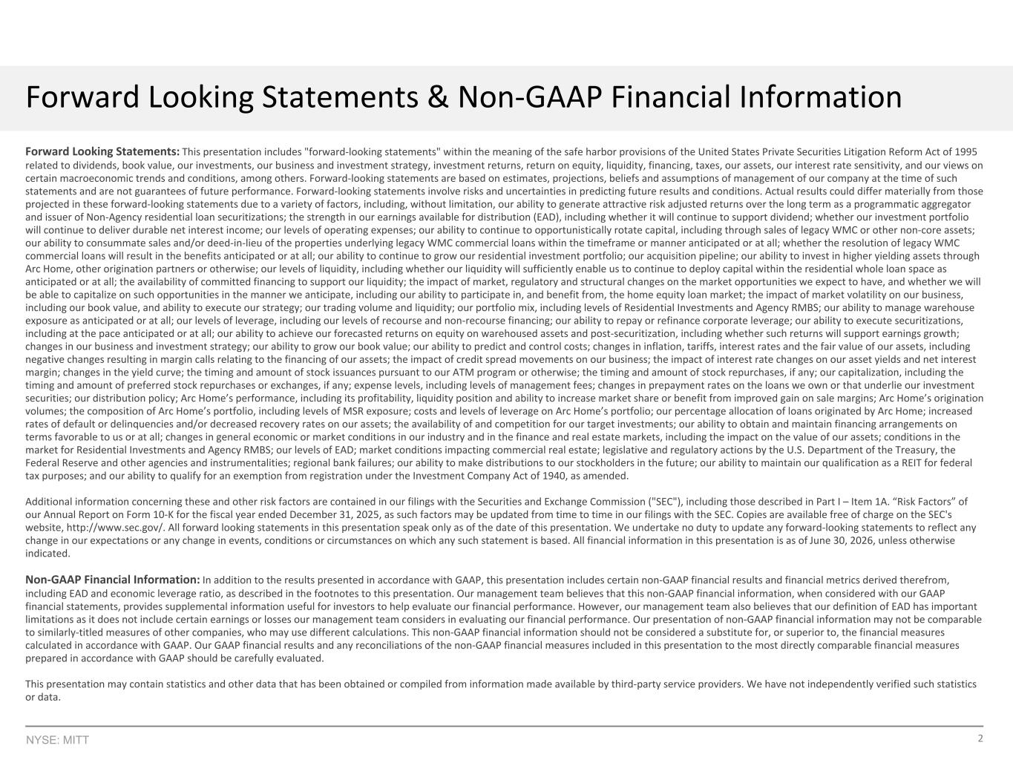
2NYSE: MITT Forward Looking Statements & Non-GAAP Financial Information Forward Looking Statements: This presentation includes "forward-looking statements" within the meaning of the safe harbor provisions of the United States Private Securities Litigation Reform Act of 1995 related to dividends, book value, our investments, our business and investment strategy, investment returns, return on equity, liquidity, financing, taxes, our assets, our interest rate sensitivity, and our views on certain macroeconomic trends and conditions, among others. Forward-looking statements are based on estimates, projections, beliefs and assumptions of management of our company at the time of such statements and are not guarantees of future performance. Forward-looking statements involve risks and uncertainties in predicting future results and conditions. Actual results could differ materially from those projected in these forward-looking statements due to a variety of factors, including, without limitation, our ability to generate attractive risk adjusted returns over the long term as a programmatic aggregator and issuer of Non-Agency residential loan securitizations; the strength in our earnings available for distribution (EAD), including whether it will continue to support dividend; whether our investment portfolio will continue to deliver durable net interest income; our levels of operating expenses; our ability to continue to opportunistically rotate capital, including through sales of legacy WMC or other non-core assets; our ability to consummate sales and/or deed-in-lieu of the properties underlying legacy WMC commercial loans within the timeframe or manner anticipated or at all; whether the resolution of legacy WMC commercial loans will result in the benefits anticipated or at all; our ability to continue to grow our residential investment portfolio; our acquisition pipeline; our ability to invest in higher yielding assets through Arc Home, other origination partners or otherwise; our levels of liquidity, including whether our liquidity will sufficiently enable us to continue to deploy capital within the residential whole loan space as anticipated or at all; the availability of committed financing to support our liquidity; the impact of market, regulatory and structural changes on the market opportunities we expect to have, and whether we will be able to capitalize on such opportunities in the manner we anticipate, including our ability to participate in, and benefit from, the home equity loan market; the impact of market volatility on our business, including our book value, and ability to execute our strategy; our trading volume and liquidity; our portfolio mix, including levels of Residential Investments and Agency RMBS; our ability to manage warehouse exposure as anticipated or at all; our levels of leverage, including our levels of recourse and non-recourse financing; our ability to repay or refinance corporate leverage; our ability to execute securitizations, including at the pace anticipated or at all; our ability to achieve our forecasted returns on equity on warehoused assets and post-securitization, including whether such returns will support earnings growth; changes in our business and investment strategy; our ability to grow our book value; our ability to predict and control costs; changes in inflation, tariffs, interest rates and the fair value of our assets, including negative changes resulting in margin calls relating to the financing of our assets; the impact of credit spread movements on our business; the impact of interest rate changes on our asset yields and net interest margin; changes in the yield curve; the timing and amount of stock issuances pursuant to our ATM program or otherwise; the timing and amount of stock repurchases, if any; our capitalization, including the timing and amount of preferred stock repurchases or exchanges, if any; expense levels, including levels of management fees; changes in prepayment rates on the loans we own or that underlie our investment securities; our distribution policy; Arc Home’s performance, including its profitability, liquidity position and ability to increase market share or benefit from improved gain on sale margins; Arc Home’s origination volumes; the composition of Arc Home’s portfolio, including levels of MSR exposure; costs and levels of leverage on Arc Home’s portfolio; our percentage allocation of loans originated by Arc Home; increased rates of default or delinquencies and/or decreased recovery rates on our assets; the availability of and competition for our target investments; our ability to obtain and maintain financing arrangements on terms favorable to us or at all; changes in general economic or market conditions in our industry and in the finance and real estate markets, including the impact on the value of our assets; conditions in the market for Residential Investments and Agency RMBS; our levels of EAD; market conditions impacting commercial real estate; legislative and regulatory actions by the U.S. Department of the Treasury, the Federal Reserve and other agencies and instrumentalities; regional bank failures; our ability to make distributions to our stockholders in the future; our ability to maintain our qualification as a REIT for federal tax purposes; and our ability to qualify for an exemption from registration under the Investment Company Act of 1940, as amended. Additional information concerning these and other risk factors are contained in our filings with the Securities and Exchange Commission ("SEC"), including those described in Part I – Item 1A. “Risk Factors” of our Annual Report on Form 10-K for the fiscal year ended December 31, 2025, as such factors may be updated from time to time in our filings with the SEC. Copies are available free of charge on the SEC's website, http://www.sec.gov/. All forward looking statements in this presentation speak only as of the date of this presentation. We undertake no duty to update any forward-looking statements to reflect any change in our expectations or any change in events, conditions or circumstances on which any such statement is based. All financial information in this presentation is as of June 30, 2026, unless otherwise indicated. Non-GAAP Financial Information: In addition to the results presented in accordance with GAAP, this presentation includes certain non-GAAP financial results and financial metrics derived therefrom, including EAD and economic leverage ratio, as described in the footnotes to this presentation. Our management team believes that this non-GAAP financial information, when considered with our GAAP financial statements, provides supplemental information useful for investors to help evaluate our financial performance. However, our management team also believes that our definition of EAD has important limitations as it does not include certain earnings or losses our management team considers in evaluating our financial performance. Our presentation of non-GAAP financial information may not be comparable to similarly-titled measures of other companies, who may use different calculations. This non-GAAP financial information should not be considered a substitute for, or superior to, the financial measures calculated in accordance with GAAP. Our GAAP financial results and any reconciliations of the non-GAAP financial measures included in this presentation to the most directly comparable financial measures prepared in accordance with GAAP should be carefully evaluated. This presentation may contain statistics and other data that has been obtained or compiled from information made available by third-party service providers. We have not independently verified such statistics or data.

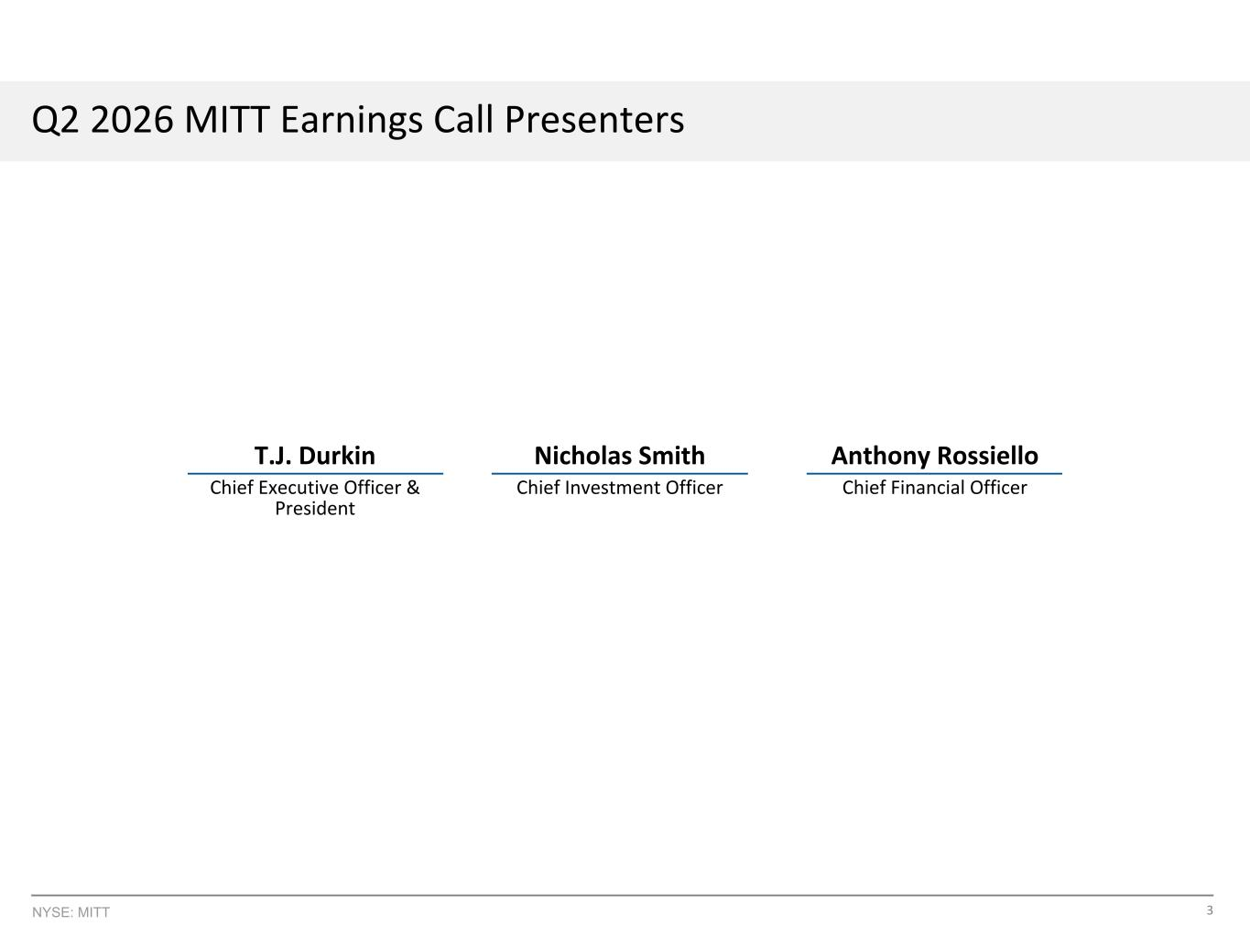
3NYSE: MITT Q2 2026 MITT Earnings Call Presenters T.J. Durkin Nicholas Smith Anthony Rossiello Chief Executive Officer & President Chief Investment Officer Chief Financial Officer

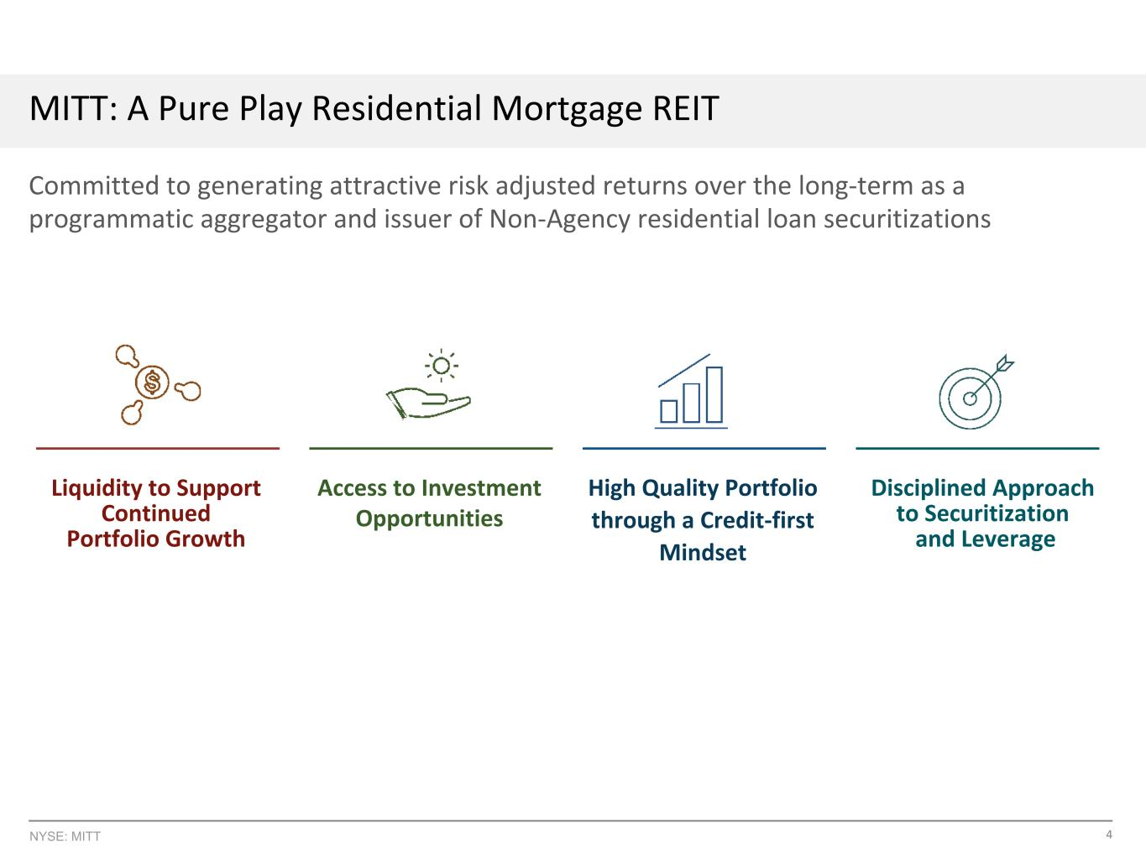
4NYSE: MITT MITT: A Pure Play Residential Mortgage REIT Committed to generating attractive risk adjusted returns over the long-term as a programmatic aggregator and issuer of Non-Agency residential loan securitizations Liquidity to Support Continued Portfolio Growth Access to Investment Opportunities High Quality Portfolio through a Credit-first Mindset Disciplined Approach to Securitization and Leverage

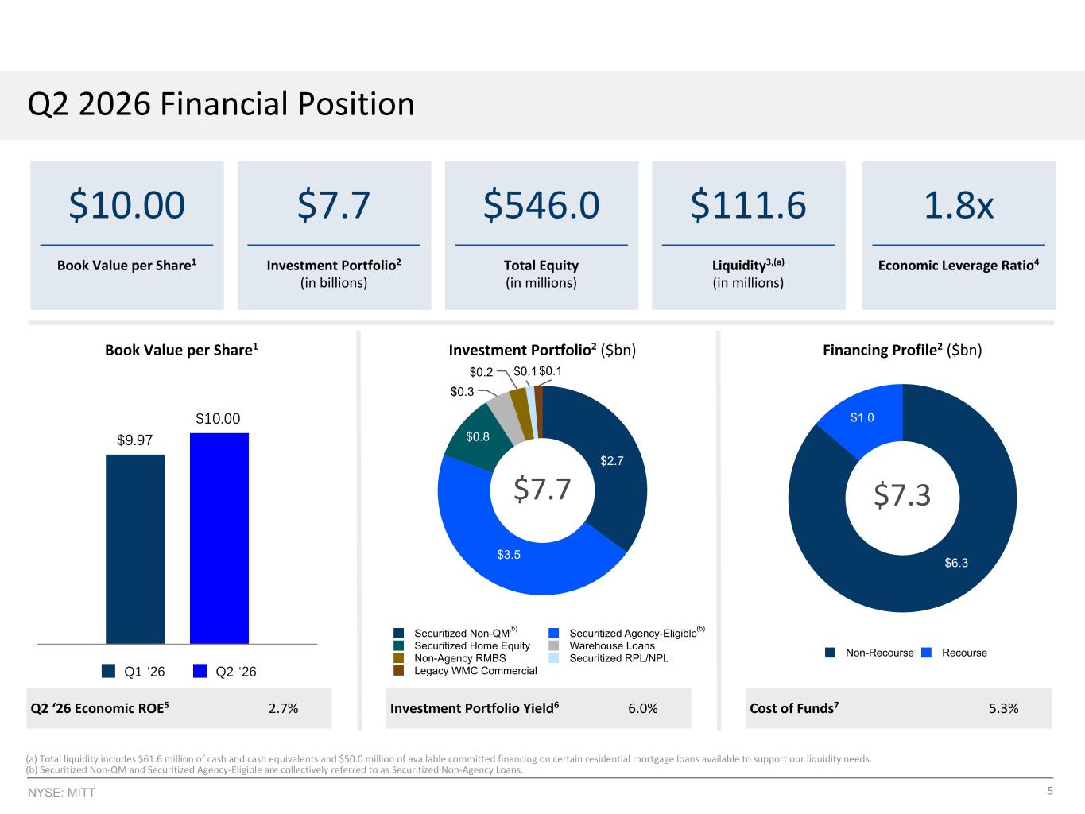
5NYSE: MITT $9.97 $10.00 Q1 ‘26 Q2 ‘26 $2.7 $3.5 $0.8 $0.3 $0.2 $0.1 $0.1 Securitized Non-QM Securitized Agency-Eligible Securitized Home Equity Warehouse Loans Non-Agency RMBS Securitized RPL/NPL Legacy WMC Commercial Q2 2026 Financial Position Cost of Funds7 5.3% $7.7 Investment Portfolio2 (in billions) $10.00 Book Value per Share1 $546.0 Total Equity (in millions) $111.6 Liquidity3,(a) (in millions) 1.8x Economic Leverage Ratio4 Investment Portfolio2 ($bn) Financing Profile2 ($bn)Book Value per Share1 Q2 ‘26 Economic ROE5 2.7% (5.5)% Investment Portfolio Yield6 6.0% $6.3 $1.0 Non-Recourse Recourse $7.3$7.7 (a) Total liquidity includes $61.6 million of cash and cash equivalents and $50.0 million of available committed financing on certain residential mortgage loans available to support our liquidity needs. (b) Securitized Non-QM and Securitized Agency-Eligible are collectively referred to as Securitized Non-Agency Loans. (b) (b)

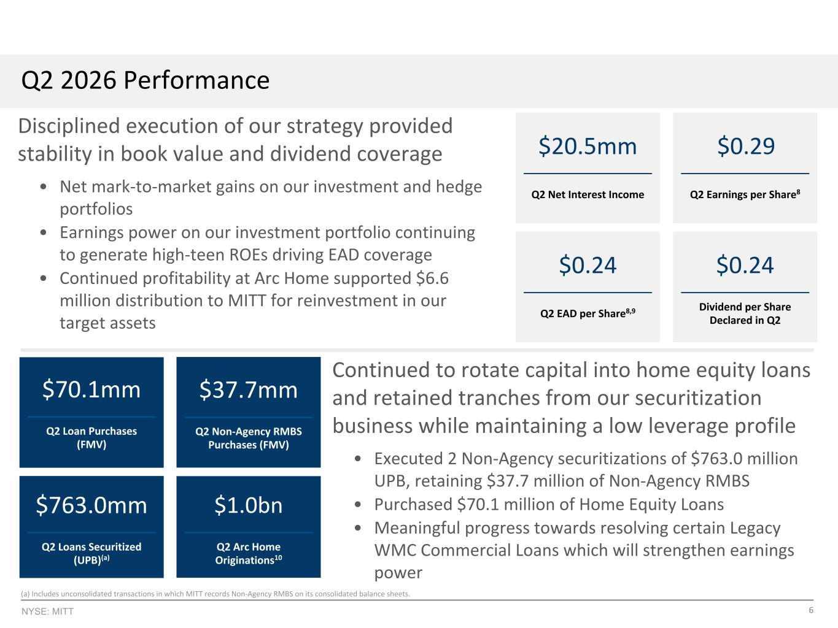
6NYSE: MITT Continued to rotate capital into home equity loans and retained tranches from our securitization business while maintaining a low leverage profile • Executed 2 Non-Agency securitizations of $763.0 million UPB, retaining $37.7 million of Non-Agency RMBS • Purchased $70.1 million of Home Equity Loans • Meaningful progress towards resolving certain Legacy WMC Commercial Loans which will strengthen earnings power Q2 2026 Performance $20.5mm Q2 Net Interest Income $0.29 Q2 Earnings per Share8 $0.24 Q2 EAD per Share8,9 $0.24 Dividend per Share Declared in Q2 $70.1mm Q2 Loan Purchases (FMV) $37.7mm Q2 Non-Agency RMBS Purchases (FMV) $763.0mm Q2 Loans Securitized (UPB)(a) $1.0bn Q2 Arc Home Originations10 (a) Includes unconsolidated transactions in which MITT records Non-Agency RMBS on its consolidated balance sheets. Disciplined execution of our strategy provided stability in book value and dividend coverage • Net mark-to-market gains on our investment and hedge portfolios • Earnings power on our investment portfolio continuing to generate high-teen ROEs driving EAD coverage • Continued profitability at Arc Home supported $6.6 million distribution to MITT for reinvestment in our target assets

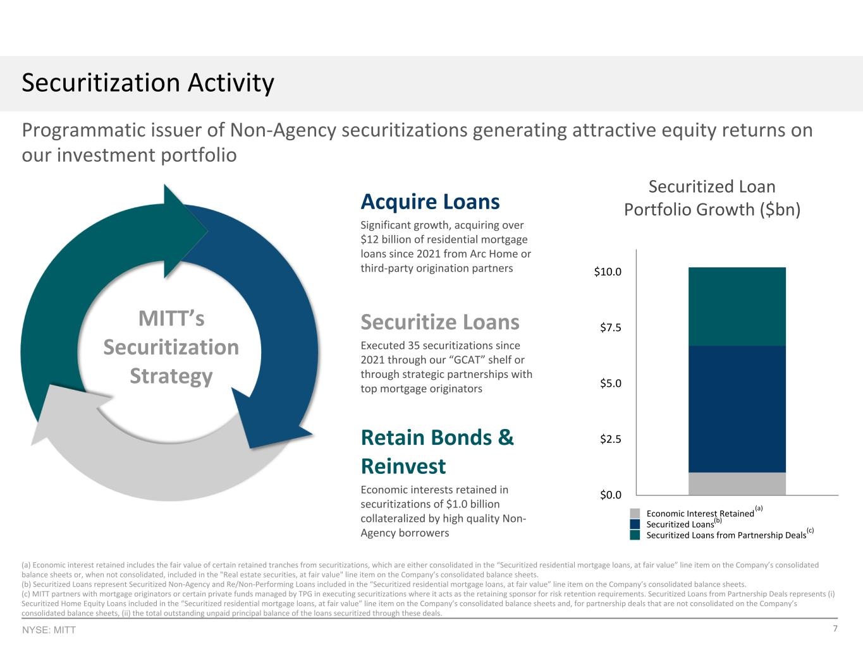
7NYSE: MITT (a) Economic interest retained includes the fair value of certain retained tranches from securitizations, which are either consolidated in the “Securitized residential mortgage loans, at fair value” line item on the Company’s consolidated balance sheets or, when not consolidated, included in the "Real estate securities, at fair value" line item on the Company’s consolidated balance sheets. (b) Securitized Loans represent Securitized Non-Agency and Re/Non-Performing Loans included in the “Securitized residential mortgage loans, at fair value” line item on the Company’s consolidated balance sheets. (c) MITT partners with mortgage originators or certain private funds managed by TPG in executing securitizations where it acts as the retaining sponsor for risk retention requirements. Securitized Loans from Partnership Deals represents (i) Securitized Home Equity Loans included in the “Securitized residential mortgage loans, at fair value” line item on the Company’s consolidated balance sheets and, for partnership deals that are not consolidated on the Company’s consolidated balance sheets, (ii) the total outstanding unpaid principal balance of the loans securitized through these deals. Economic Interest Retained Securitized Loans Securitized Loans from Partnership Deals Q4 ‘2 1 Q2 ‘2 6 $0.0 $3.5 $7.0 $10.5 Securitization Activity Programmatic issuer of Non-Agency securitizations generating attractive equity returns on our investment portfolio Securitized Loan Portfolio Growth ($bn) (a) (c) (b) Acquire Loans Significant growth, acquiring over $12 billion of residential mortgage loans since 2021 from Arc Home or third-party origination partners Retain Bonds & Reinvest Economic interests retained in securitizations of $1.0 billion collateralized by high quality Non- Agency borrowers MITT’s Securitization Strategy Securitize Loans Executed 35 securitizations since 2021 through our “GCAT” shelf or through strategic partnerships with top mortgage originators Economic Interest Retained Securitized Loans Securitized Loans from Partnership Deals $0.0 $2.5 $5.0 $7.5 $10.0 Example Total Return Performance Economic Interest Retained Securitized Loans Securitized Loans from Partnership Deals

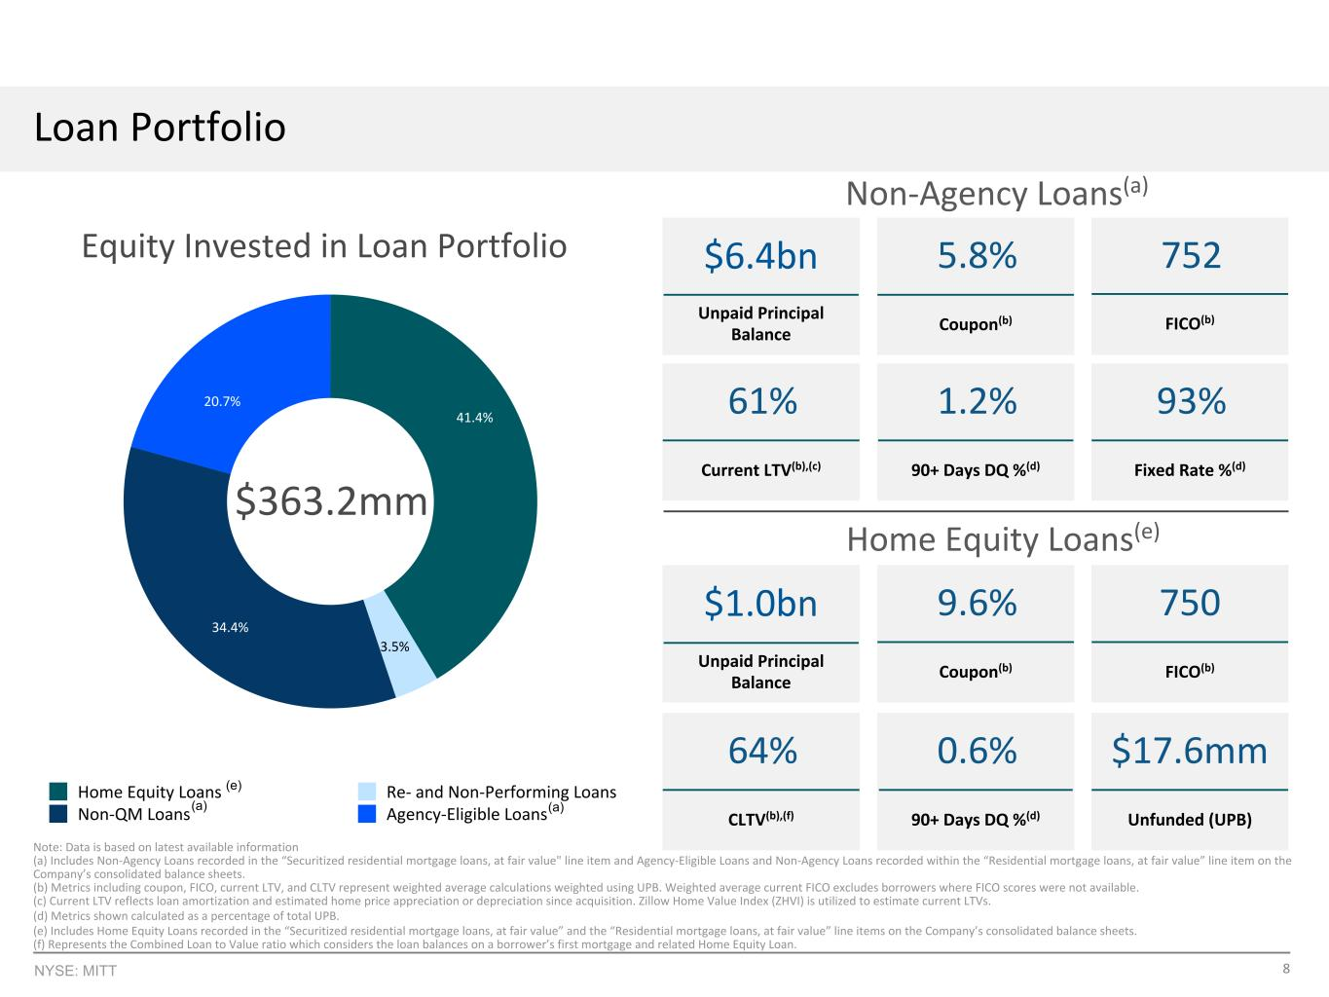
8NYSE: MITT Note: Data is based on latest available information (a) Includes Non-Agency Loans recorded in the “Securitized residential mortgage loans, at fair value" line item and Agency-Eligible Loans and Non-Agency Loans recorded within the “Residential mortgage loans, at fair value” line item on the Company’s consolidated balance sheets. (b) Metrics including coupon, FICO, current LTV, and CLTV represent weighted average calculations weighted using UPB. Weighted average current FICO excludes borrowers where FICO scores were not available. (c) Current LTV reflects loan amortization and estimated home price appreciation or depreciation since acquisition. Zillow Home Value Index (ZHVI) is utilized to estimate current LTVs. (d) Metrics shown calculated as a percentage of total UPB. (e) Includes Home Equity Loans recorded in the “Securitized residential mortgage loans, at fair value” and the “Residential mortgage loans, at fair value” line items on the Company’s consolidated balance sheets. (f) Represents the Combined Loan to Value ratio which considers the loan balances on a borrower’s first mortgage and related Home Equity Loan. Loan Portfolio $1.0bn Unpaid Principal Balance 64% CLTV(b),(f) 0.6% 90+ Days DQ %(d) 750 FICO(b) $17.6mm Unfunded (UPB) $6.4bn Unpaid Principal Balance 61% Current LTV(b),(c) 1.2% 90+ Days DQ %(d) 93% Fixed Rate %(d) 5.8% Coupon(b) Home Equity Loans(e) 41.4% 3.5% 34.4% 20.7% Home Equity Loans Re- and Non-Performing Loans Non-QM Loans Agency-Eligible Loans 9.6% Coupon(b) Equity Invested in Loan Portfolio Non-Agency Loans(a) 752 FICO(b) $363.2mm (e) (a) (a)

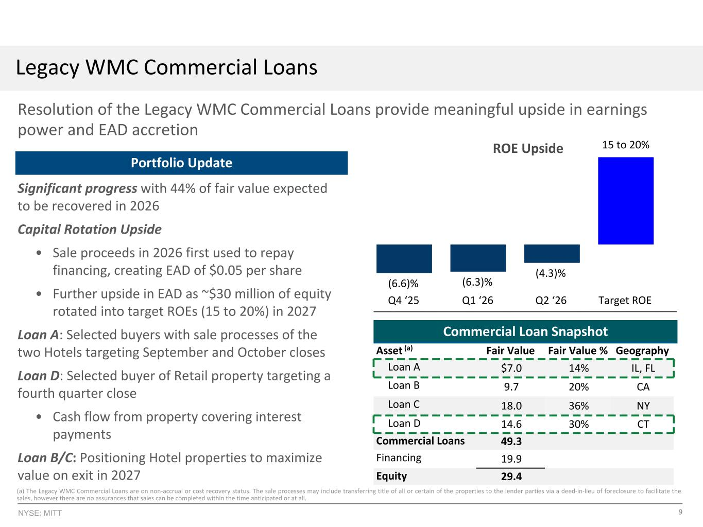
9NYSE: MITT Significant progress with 44% of fair value expected to be recovered in 2026 Capital Rotation Upside • Sale proceeds in 2026 first used to repay financing, creating EAD of $0.05 per share • Further upside in EAD as ~$30 million of equity rotated into target ROEs (15 to 20%) in 2027 Loan A: Selected buyers with sale processes of the two Hotels targeting September and October closes Loan D: Selected buyer of Retail property targeting a fourth quarter close • Cash flow from property covering interest payments Loan B/C: Positioning Hotel properties to maximize value on exit in 2027 (6.6)% (6.3)% (4.3)% Q4 ‘25 Q1 ‘26 Q2 ‘26 Target ROE Resolution of the Legacy WMC Commercial Loans provide meaningful upside in earnings power and EAD accretion Commercial Loan Snapshot Legacy WMC Commercial Loans 38.2% 48.4% 10.6% 2.8% Hotel Retail Office Other 13.0% 5.8% 25.8% 55.4% CMBS - Conduit Fixed Rate CMBS - SASB Floating Rate CMBS - SASB Fixed Rate Commercial Loans ROE Upside 15 to 20% $92.0mm of Fair Value (by Collateral Type) CMBS Summary • $42.7 million fair value / $23.7 million equity • Weighted average price of 52%, allowing for book value upside • Weighted average unlevered yield of 16.2%6,(b) • Weighted average life of 1.6 years (a) The Legacy WMC Commercial Loans are on non-accrual or cost recovery status. The sale processes may include transferring title of all or certain of the properties to the lender parties via a deed-in-lieu of foreclosure to facilitate the sales, however there are no assurances that sales can be completed within the time anticipated or at all. Asset (a) Fair Value Fair Value % Geography Loan A $7.0 14% IL, FL Loan B 9.7 20% CA Loan C 18.0 36% NY Loan D 14.6 30% CT Commercial Loans 49.3 Financing 19.9 Equity 29.4 Portfolio Update Q4 ‘25 Q1 ‘26 Q2 ‘26 15-20% (6.6)% (6.3)% (4.3)% Target ROE

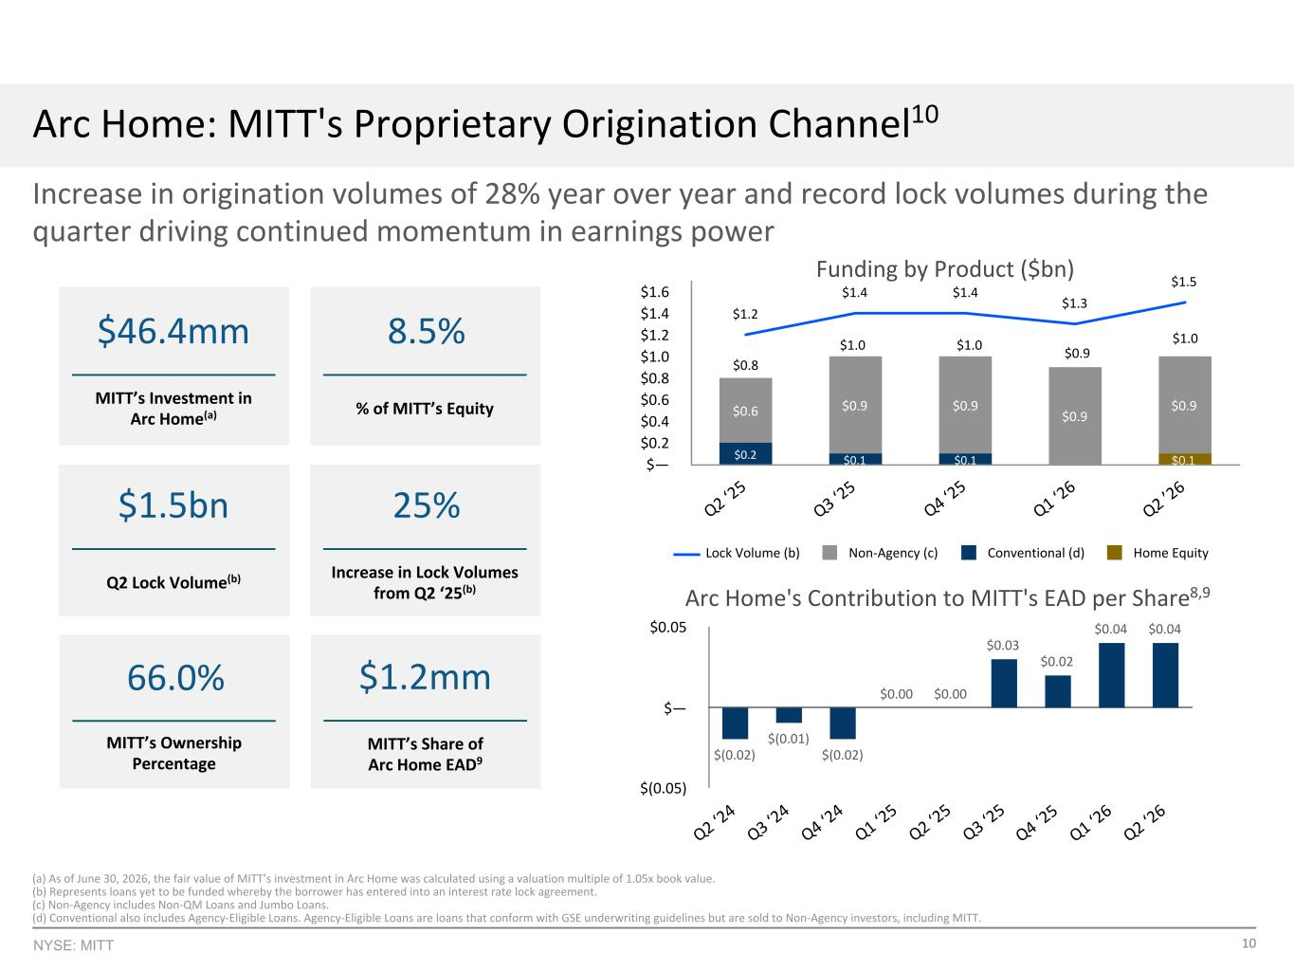
10NYSE: MITT Increase in origination volumes of 28% year over year and record lock volumes during the quarter driving continued momentum in earnings power Arc Home: MITT's Proprietary Origination Channel10 66.0% MITT’s Ownership Percentage $1.2mm MITT’s Share of Arc Home EAD9 $46.4mm MITT’s Investment in Arc Home(a) $0.1$0.2 $0.1 $0.1 $0.6 $0.9 $0.9 $0.9 $0.9 $1.2 $1.4 $1.4 $1.3 $1.5 Lock Volume (b) Non-Agency (c) Conventional (d) Home Equity Q2 ‘2 5 Q3 ‘2 5 Q4 ‘2 5 Q1 ‘2 6 Q2 ’2 6 $— $0.2 $0.4 $0.6 $0.8 $1.0 $1.2 $1.4 $1.6 Funding by Product ($bn) $0.8 $1.0 $(0.02) $(0.01) $(0.02) $0.00 $0.00 $0.03 $0.02 $0.04 $0.04 Q2 ‘2 4 Q3 ‘2 4 Q4 ‘2 4 Q1 ‘2 5 Q2 ‘2 5 Q3 ‘2 5 Q4 ‘2 5 Q1 ‘2 6 Q2 ‘2 6 $(0.05) $— $0.05 Arc Home's Contribution to MITT's EAD per Share8,9 (a) As of June 30, 2026, the fair value of MITT’s investment in Arc Home was calculated using a valuation multiple of 1.05x book value. (b) Represents loans yet to be funded whereby the borrower has entered into an interest rate lock agreement. (c) Non-Agency includes Non-QM Loans and Jumbo Loans. (d) Conventional also includes Agency-Eligible Loans. Agency-Eligible Loans are loans that conform with GSE underwriting guidelines but are sold to Non-Agency investors, including MITT. 8.5% % of MITT’s Equity $1.5bn Q2 Lock Volume(b) 25% Increase in Lock Volumes from Q2 ‘25(b) $1.0 GOS Margin Q1 ‘25 Q2 ‘25 Q3 ‘25 Q4 ‘25 Q1 ‘26 100 125 150 $0.9 $1.0

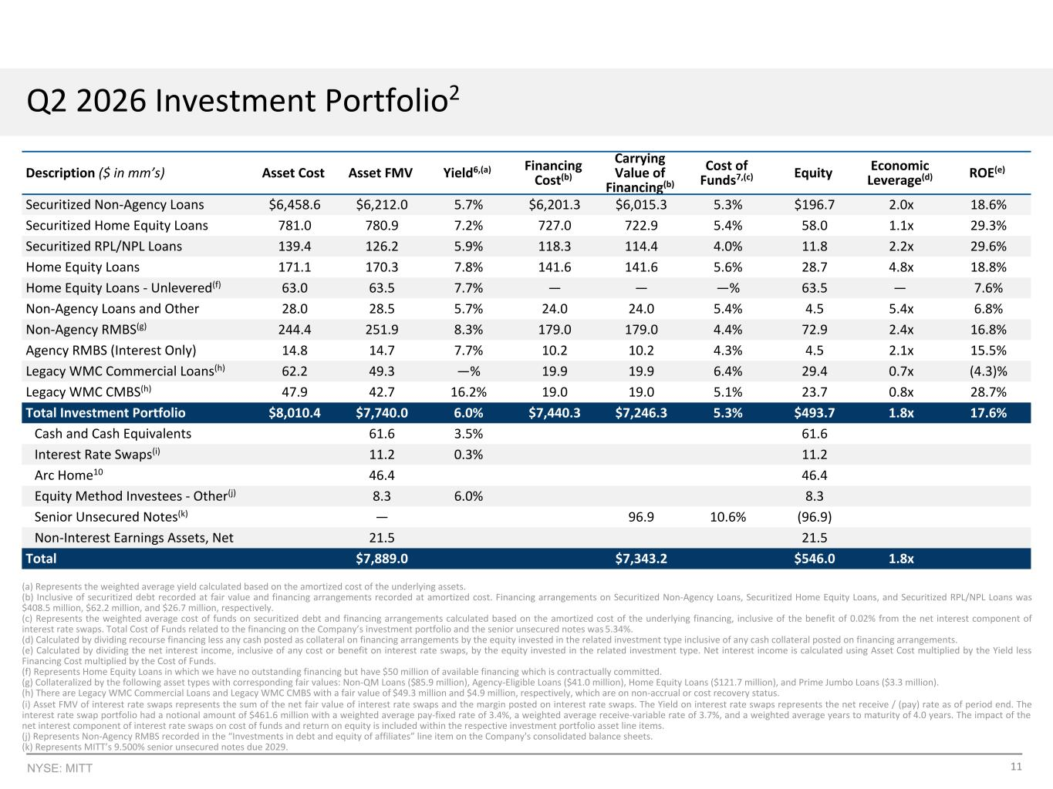
11NYSE: MITT Description ($ in mm’s) Asset Cost Asset FMV Yield6,(a) Financing Cost(b) Carrying Value of Financing(b) Cost of Funds7,(c) Equity Economic Leverage(d) ROE(e) Securitized Non-Agency Loans $6,458.6 $6,212.0 5.7% $6,201.3 $6,015.3 5.3% $196.7 2.0x 18.6% Securitized Home Equity Loans 781.0 780.9 7.2% 727.0 722.9 5.4% 58.0 1.1x 29.3% Securitized RPL/NPL Loans 139.4 126.2 5.9% 118.3 114.4 4.0% 11.8 2.2x 29.6% Home Equity Loans 171.1 170.3 7.8% 141.6 141.6 5.6% 28.7 4.8x 18.8% Home Equity Loans - Unlevered(f) 63.0 63.5 7.7% — — —% 63.5 — 7.6% Non-Agency Loans and Other 28.0 28.5 5.7% 24.0 24.0 5.4% 4.5 5.4x 6.8% Non-Agency RMBS(g) 244.4 251.9 8.3% 179.0 179.0 4.4% 72.9 2.4x 16.8% Agency RMBS (Interest Only) 14.8 14.7 7.7% 10.2 10.2 4.3% 4.5 2.1x 15.5% Legacy WMC Commercial Loans(h) 62.2 49.3 —% 19.9 19.9 6.4% 29.4 0.7x (4.3)% Legacy WMC CMBS(h) 47.9 42.7 16.2% 19.0 19.0 5.1% 23.7 0.8x 28.7% Total Investment Portfolio $8,010.4 $7,740.0 6.0% $7,440.3 $7,246.3 5.3% $493.7 1.8x 17.6% Cash and Cash Equivalents 61.6 3.5% 61.6 Interest Rate Swaps(i) 11.2 0.3% 11.2 Arc Home10 46.4 46.4 Equity Method Investees - Other(j) 8.3 6.0% 8.3 Senior Unsecured Notes(k) — 96.9 10.6% (96.9) Non-Interest Earnings Assets, Net 21.5 21.5 Total $7,889.0 $7,343.2 $546.0 1.8x (a) Represents the weighted average yield calculated based on the amortized cost of the underlying assets. (b) Inclusive of securitized debt recorded at fair value and financing arrangements recorded at amortized cost. Financing arrangements on Securitized Non-Agency Loans, Securitized Home Equity Loans, and Securitized RPL/NPL Loans was $408.5 million, $62.2 million, and $26.7 million, respectively. (c) Represents the weighted average cost of funds on securitized debt and financing arrangements calculated based on the amortized cost of the underlying financing, inclusive of the benefit of 0.02% from the net interest component of interest rate swaps. Total Cost of Funds related to the financing on the Company’s investment portfolio and the senior unsecured notes was 5.34%. (d) Calculated by dividing recourse financing less any cash posted as collateral on financing arrangements by the equity invested in the related investment type inclusive of any cash collateral posted on financing arrangements. (e) Calculated by dividing the net interest income, inclusive of any cost or benefit on interest rate swaps, by the equity invested in the related investment type. Net interest income is calculated using Asset Cost multiplied by the Yield less Financing Cost multiplied by the Cost of Funds. (f) Represents Home Equity Loans in which we have no outstanding financing but have $50 million of available financing which is contractually committed. (g) Collateralized by the following asset types with corresponding fair values: Non-QM Loans ($85.9 million), Agency-Eligible Loans ($41.0 million), Home Equity Loans ($121.7 million), and Prime Jumbo Loans ($3.3 million). (h) There are Legacy WMC Commercial Loans and Legacy WMC CMBS with a fair value of $49.3 million and $4.9 million, respectively, which are on non-accrual or cost recovery status. (i) Asset FMV of interest rate swaps represents the sum of the net fair value of interest rate swaps and the margin posted on interest rate swaps. The Yield on interest rate swaps represents the net receive / (pay) rate as of period end. The interest rate swap portfolio had a notional amount of $461.6 million with a weighted average pay-fixed rate of 3.4%, a weighted average receive-variable rate of 3.7%, and a weighted average years to maturity of 4.0 years. The impact of the net interest component of interest rate swaps on cost of funds and return on equity is included within the respective investment portfolio asset line items. (j) Represents Non-Agency RMBS recorded in the “Investments in debt and equity of affiliates” line item on the Company's consolidated balance sheets. (k) Represents MITT’s 9.500% senior unsecured notes due 2029. Q2 2026 Investment Portfolio2

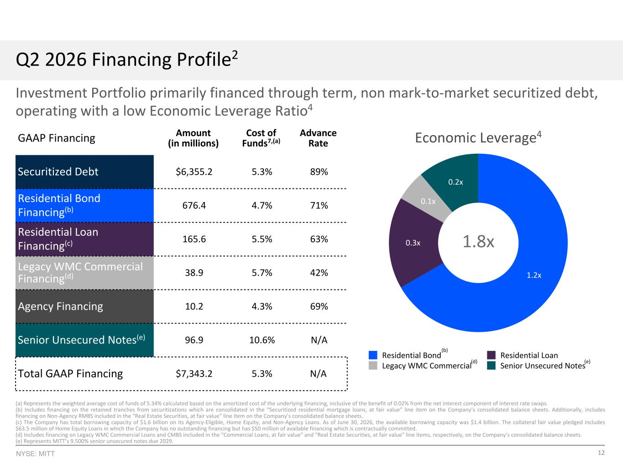
12NYSE: MITT Investment Portfolio primarily financed through term, non mark-to-market securitized debt, operating with a low Economic Leverage Ratio4 1.4x 2.5x 1.5x 1.4x 1.6x Residential Agency Commercial Unsecured Notes Q1 ‘ 24 Q2 ‘ 24 Q3 ‘ 24 Q4 ‘ 24 Q1 ‘ 25 0.0x 1.0x 2.0x 3.0x (a) Represents the weighted average cost of funds of 5.34% calculated based on the amortized cost of the underlying financing, inclusive of the benefit of 0.02% from the net interest component of interest rate swaps. (b) Includes financing on the retained tranches from securitizations which are consolidated in the “Securitized residential mortgage loans, at fair value” line item on the Company’s consolidated balance sheets. Additionally, includes financing on Non-Agency RMBS included in the “Real Estate Securities, at fair value” line item on the Company’s consolidated balance sheets. (c) The Company has total borrowing capacity of $1.6 billion on its Agency-Eligible, Home Equity, and Non-Agency Loans. As of June 30, 2026, the available borrowing capacity was $1.4 billion. The collateral fair value pledged includes $63.5 million of Home Equity Loans in which the Company has no outstanding financing but has $50 million of available financing which is contractually committed. (d) Includes financing on Legacy WMC Commercial Loans and CMBS included in the "Commercial Loans, at fair value" and “Real Estate Securities, at fair value” line items, respectively, on the Company’s consolidated balance sheets. (e) Represents MITT’s 9.500% senior unsecured notes due 2029. Residential, 11.6% Commercial, 0.5% Unsecured Notes, 1.3% Securitized Debt, 86.5% GAAP Financing Amount (in millions) Cost of Funds7,(a) Advance Rate Securitized Debt $6,355.2 5.3% 89% Residential Bond Financing(b) 676.4 4.7% 71% Residential Loan Financing(c) 165.6 5.5% 63% Legacy WMC Commercial Financing(d) 38.9 5.7% 42% Agency Financing 10.2 4.3% 69% Senior Unsecured Notes(e) 96.9 10.6% N/A Total GAAP Financing $7,343.2 5.3% N/A Q2 2026 Financing Profile2 Economic Leverage4 1.2x 0.3x 0.1x 0.2x Residential Bond Residential Loan Legacy WMC Commercial Senior Unsecured Notes 1.8x (b) (d) (e)

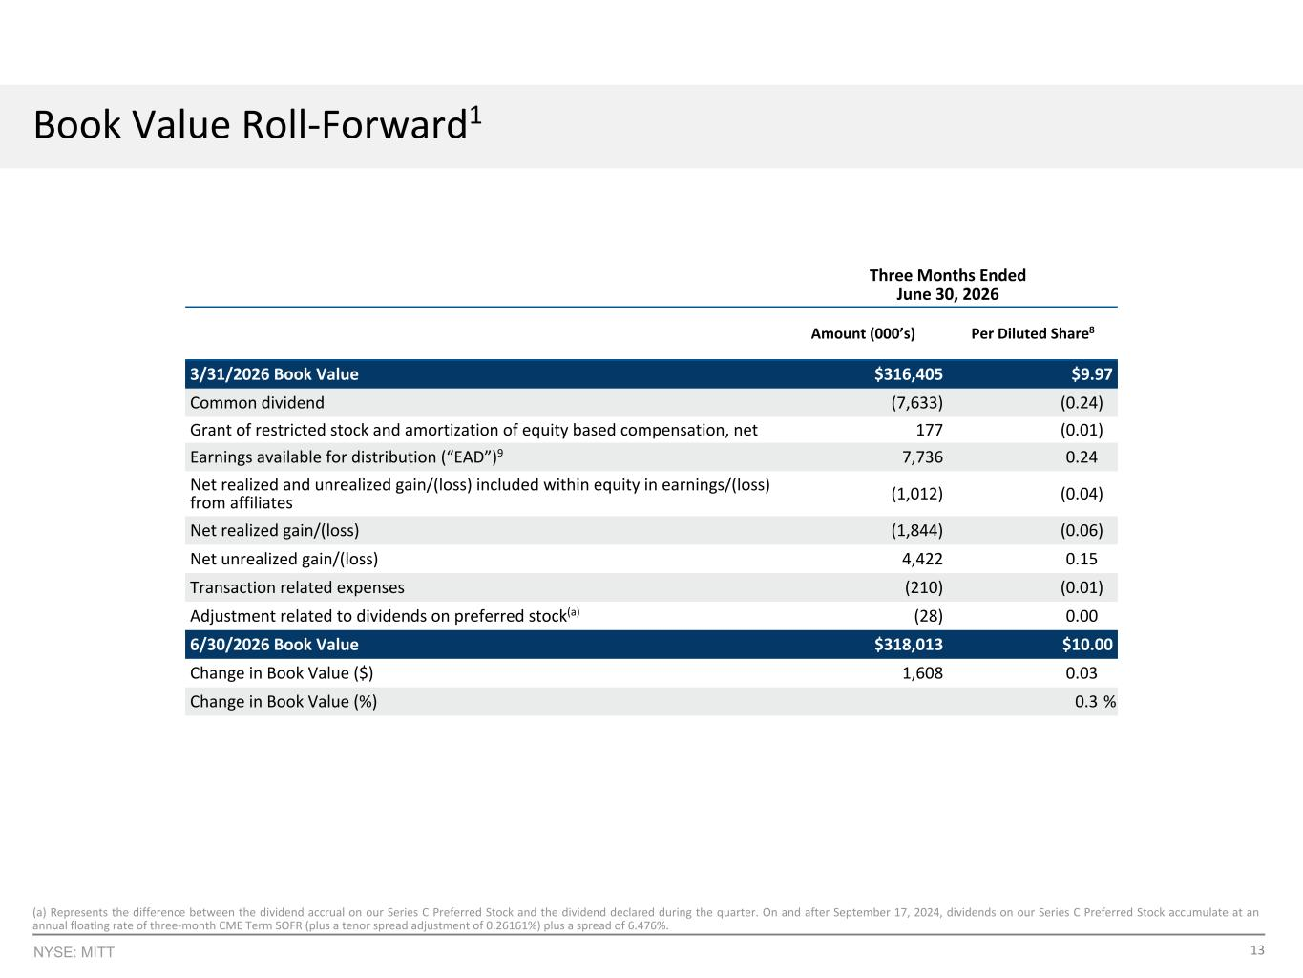
13NYSE: MITT Three Months Ended June 30, 2026 Amount (000’s) Per Diluted Share8 3/31/2026 Book Value $316,405 $9.97 Common dividend (7,633) (0.24) Grant of restricted stock and amortization of equity based compensation, net 177 (0.01) Earnings available for distribution (“EAD”)9 7,736 0.24 Net realized and unrealized gain/(loss) included within equity in earnings/(loss) from affiliates (1,012) (0.04) Net realized gain/(loss) (1,844) (0.06) Net unrealized gain/(loss) 4,422 0.15 Transaction related expenses (210) (0.01) Adjustment related to dividends on preferred stock(a) (28) 0.00 6/30/2026 Book Value $318,013 $10.00 Change in Book Value ($) 1,608 0.03 Change in Book Value (%) 0.3 % Book Value Roll-Forward1 (a) Represents the difference between the dividend accrual on our Series C Preferred Stock and the dividend declared during the quarter. On and after September 17, 2024, dividends on our Series C Preferred Stock accumulate at an annual floating rate of three-month CME Term SOFR (plus a tenor spread adjustment of 0.26161%) plus a spread of 6.476%.

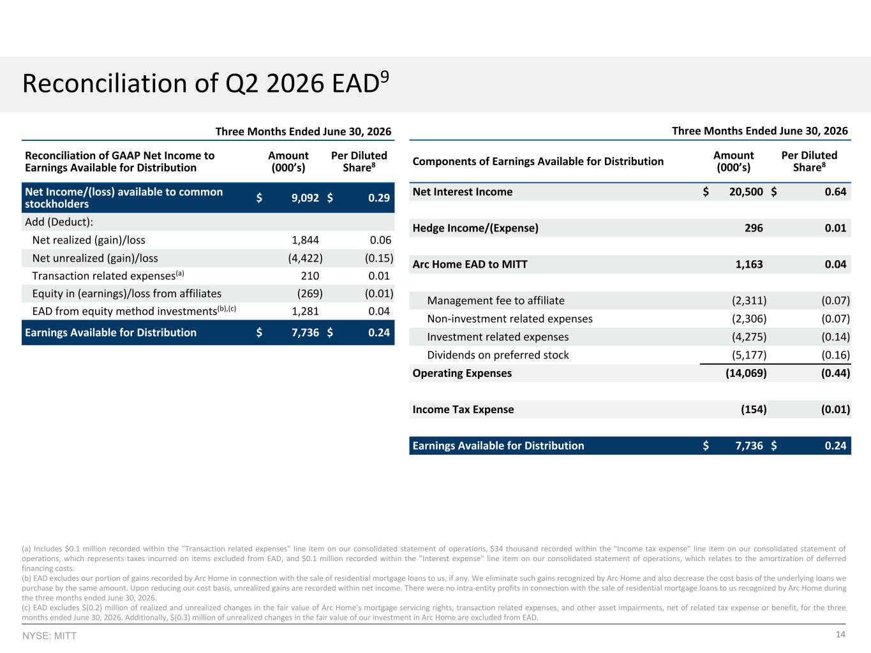
14NYSE: MITT Three Months Ended June 30, 2026 Components of Earnings Available for Distribution Amount (000’s) Per Diluted Share8 Net Interest Income $ 20,500 $ 0.64 Hedge Income/(Expense) 296 0.01 Arc Home EAD to MITT 1,163 0.04 Management fee to affiliate (2,311) (0.07) Non-investment related expenses (2,306) (0.07) Investment related expenses (4,275) (0.14) Dividends on preferred stock (5,177) (0.16) Operating Expenses (14,069) (0.44) Income Tax Expense (154) (0.01) Earnings Available for Distribution $ 7,736 $ 0.24 Reconciliation of Q2 2026 EAD9 (a) Includes $0.1 million recorded within the "Transaction related expenses" line item on our consolidated statement of operations, $34 thousand recorded within the "Income tax expense" line item on our consolidated statement of operations, which represents taxes incurred on items excluded from EAD, and $0.1 million recorded within the "Interest expense" line item on our consolidated statement of operations, which relates to the amortization of deferred financing costs. (b) EAD excludes our portion of gains recorded by Arc Home in connection with the sale of residential mortgage loans to us, if any. We eliminate such gains recognized by Arc Home and also decrease the cost basis of the underlying loans we purchase by the same amount. Upon reducing our cost basis, unrealized gains are recorded within net income. There were no intra-entity profits in connection with the sale of residential mortgage loans to us recognized by Arc Home during the three months ended June 30, 2026. (c) EAD excludes $(0.2) million of realized and unrealized changes in the fair value of Arc Home's mortgage servicing rights, transaction related expenses, and other asset impairments, net of related tax expense or benefit, for the three months ended June 30, 2026. Additionally, $(0.3) million of unrealized changes in the fair value of our investment in Arc Home are excluded from EAD. Three Months Ended June 30, 2026 Reconciliation of GAAP Net Income to Earnings Available for Distribution Amount (000’s) Per Diluted Share8 Net Income/(loss) available to common stockholders $ 9,092 $ 0.29 Add (Deduct): Net realized (gain)/loss 1,844 0.06 Net unrealized (gain)/loss (4,422) (0.15) Transaction related expenses(a) 210 0.01 Equity in (earnings)/loss from affiliates (269) (0.01) EAD from equity method investments(b),(c) 1,281 0.04 Earnings Available for Distribution $ 7,736 $ 0.24

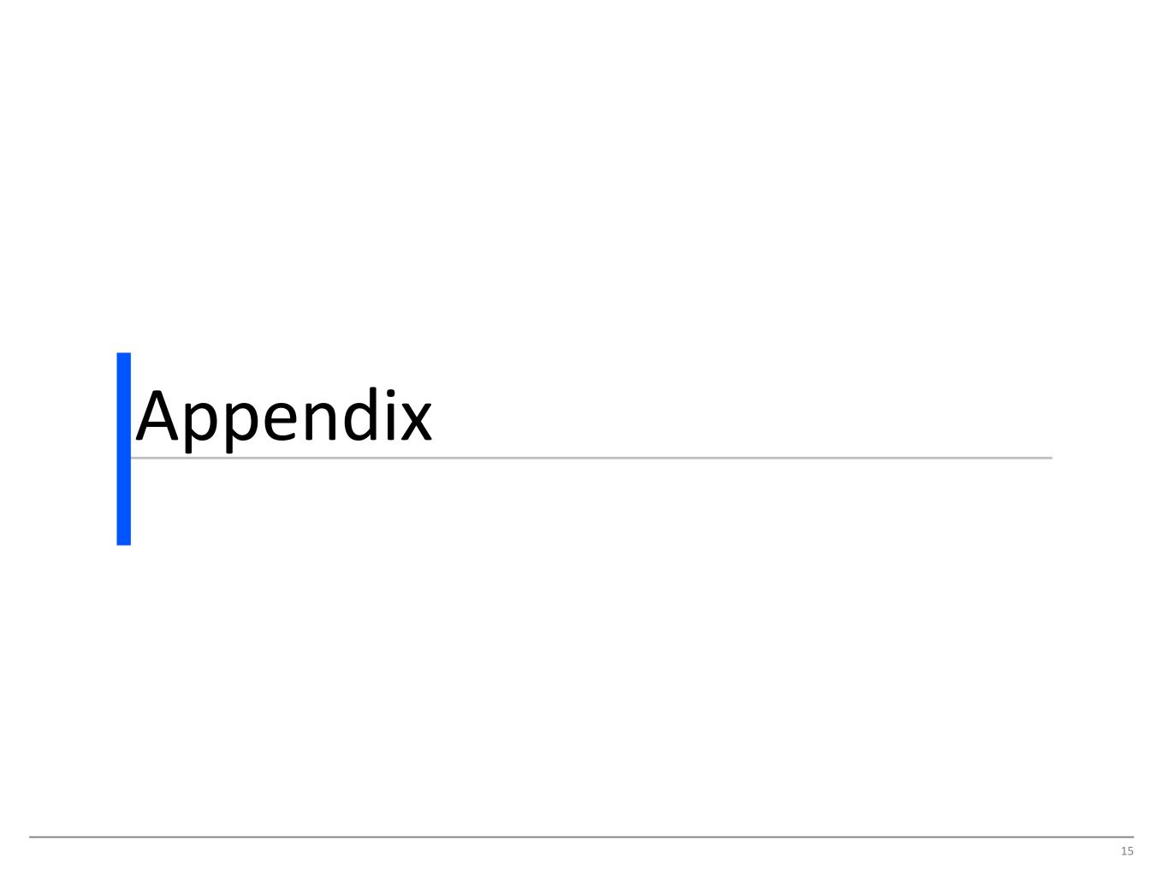
15 Appendix

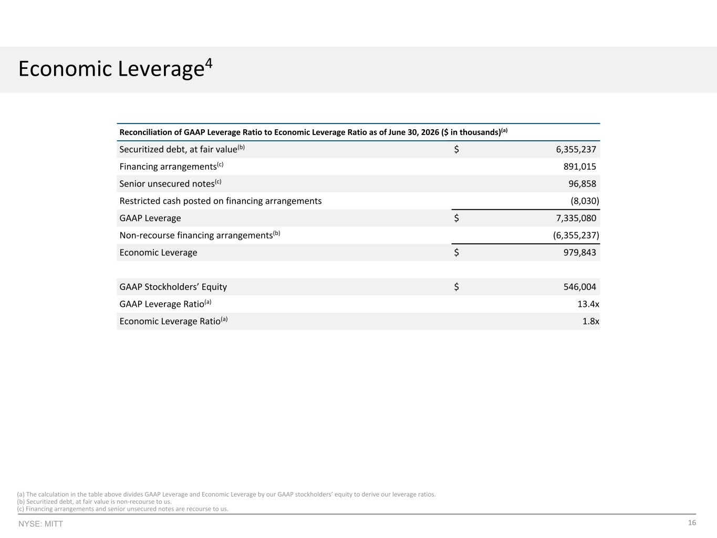
16NYSE: MITT (a) The calculation in the table above divides GAAP Leverage and Economic Leverage by our GAAP stockholders’ equity to derive our leverage ratios. (b) Securitized debt, at fair value is non-recourse to us. (c) Financing arrangements and senior unsecured notes are recourse to us. Reconciliation of GAAP Leverage Ratio to Economic Leverage Ratio as of June 30, 2026 ($ in thousands)(a) Securitized debt, at fair value(b) $ 6,355,237 Financing arrangements(c) 891,015 Senior unsecured notes(c) 96,858 Restricted cash posted on financing arrangements (8,030) GAAP Leverage $ 7,335,080 Non-recourse financing arrangements(b) (6,355,237) Economic Leverage $ 979,843 GAAP Stockholders’ Equity $ 546,004 GAAP Leverage Ratio(a) 13.4x Economic Leverage Ratio(a) 1.8x Economic Leverage4 (a) The calculation in the table above divides GAAP Leverage and Economic Leverage by our GAAP stockholders’ equity to derive our leverage ratios. (b) Securitized debt, at fair value is non-recourse to us. (c) Financing arrangements and senior unsecured notes are recourse to us.

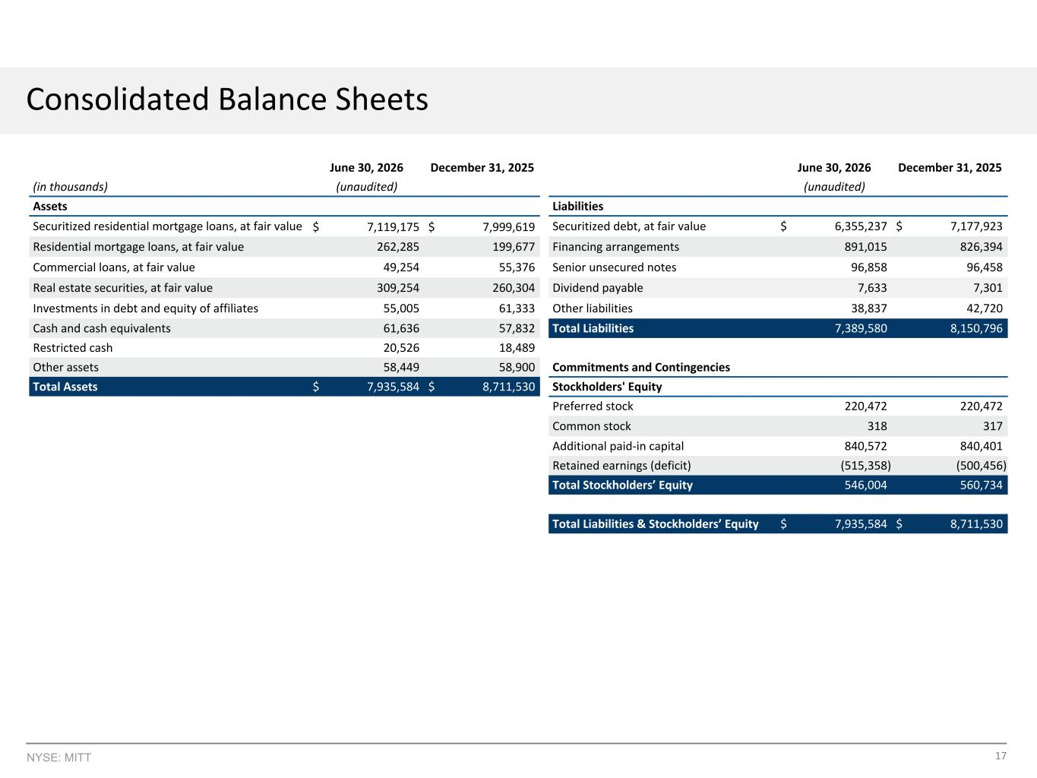
17NYSE: MITT Consolidated Balance Sheets June 30, 2026 December 31, 2025 June 30, 2026 December 31, 2025 (in thousands) (unaudited) (unaudited) Assets Liabilities Securitized residential mortgage loans, at fair value $ 7,119,175 $ 7,999,619 Securitized debt, at fair value $ 6,355,237 $ 7,177,923 Residential mortgage loans, at fair value 262,285 199,677 Financing arrangements 891,015 826,394 Commercial loans, at fair value 49,254 55,376 Senior unsecured notes 96,858 96,458 Real estate securities, at fair value 309,254 260,304 Dividend payable 7,633 7,301 Investments in debt and equity of affiliates 55,005 61,333 Other liabilities 38,837 42,720 Cash and cash equivalents 61,636 57,832 Total Liabilities 7,389,580 8,150,796 Restricted cash 20,526 18,489 Other assets 58,449 58,900 Commitments and Contingencies Total Assets $ 7,935,584 $ 8,711,530 Stockholders' Equity Preferred stock 220,472 220,472 Common stock 318 317 Additional paid-in capital 840,572 840,401 Retained earnings (deficit) (515,358) (500,456) Total Stockholders’ Equity 546,004 560,734 Total Liabilities & Stockholders’ Equity $ 7,935,584 $ 8,711,530

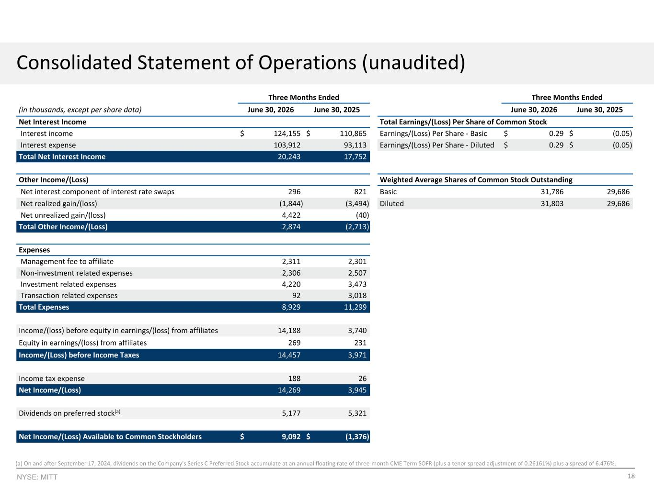
18NYSE: MITT Three Months Ended Three Months Ended (in thousands, except per share data) June 30, 2026 June 30, 2025 June 30, 2026 June 30, 2025 Net Interest Income Total Earnings/(Loss) Per Share of Common Stock Interest income $ 124,155 $ 110,865 Earnings/(Loss) Per Share - Basic $ 0.29 $ (0.05) Interest expense 103,912 93,113 Earnings/(Loss) Per Share - Diluted $ 0.29 $ (0.05) Total Net Interest Income 20,243 17,752 Other Income/(Loss) Weighted Average Shares of Common Stock Outstanding Net interest component of interest rate swaps 296 821 Basic 31,786 29,686 Net realized gain/(loss) (1,844) (3,494) Diluted 31,803 29,686 Net unrealized gain/(loss) 4,422 (40) Total Other Income/(Loss) 2,874 (2,713) Expenses Management fee to affiliate 2,311 2,301 Non-investment related expenses 2,306 2,507 Investment related expenses 4,220 3,473 Transaction related expenses 92 3,018 Total Expenses 8,929 11,299 Income/(loss) before equity in earnings/(loss) from affiliates 14,188 3,740 Equity in earnings/(loss) from affiliates 269 231 Income/(Loss) before Income Taxes 14,457 3,971 Income tax expense 188 26 Net Income/(Loss) 14,269 3,945 Dividends on preferred stock(a) 5,177 5,321 Net Income/(Loss) Available to Common Stockholders $ 9,092 $ (1,376) Consolidated Statement of Operations (unaudited) (a) On and after September 17, 2024, dividends on the Company’s Series C Preferred Stock accumulate at an annual floating rate of three-month CME Term SOFR (plus a tenor spread adjustment of 0.26161%) plus a spread of 6.476%.

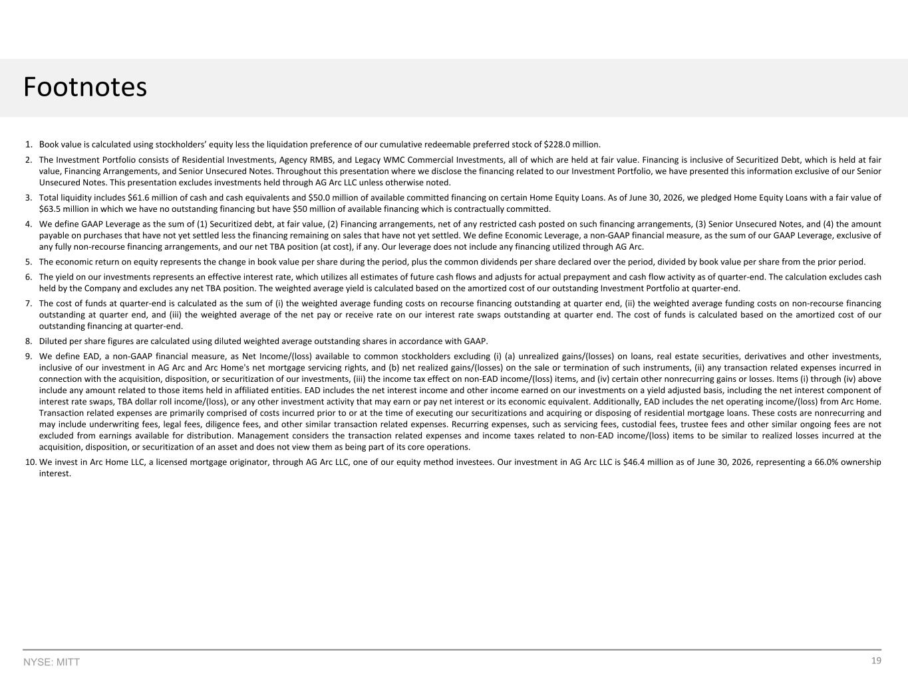
19NYSE: MITT Footnotes 1. Book value is calculated using stockholders’ equity less the liquidation preference of our cumulative redeemable preferred stock of $228.0 million. 2. The Investment Portfolio consists of Residential Investments, Agency RMBS, and Legacy WMC Commercial Investments, all of which are held at fair value. Financing is inclusive of Securitized Debt, which is held at fair value, Financing Arrangements, and Senior Unsecured Notes. Throughout this presentation where we disclose the financing related to our Investment Portfolio, we have presented this information exclusive of our Senior Unsecured Notes. This presentation excludes investments held through AG Arc LLC unless otherwise noted. 3. Total liquidity includes $61.6 million of cash and cash equivalents and $50.0 million of available committed financing on certain Home Equity Loans. As of June 30, 2026, we pledged Home Equity Loans with a fair value of $63.5 million in which we have no outstanding financing but have $50 million of available financing which is contractually committed. 4. We define GAAP Leverage as the sum of (1) Securitized debt, at fair value, (2) Financing arrangements, net of any restricted cash posted on such financing arrangements, (3) Senior Unsecured Notes, and (4) the amount payable on purchases that have not yet settled less the financing remaining on sales that have not yet settled. We define Economic Leverage, a non-GAAP financial measure, as the sum of our GAAP Leverage, exclusive of any fully non-recourse financing arrangements, and our net TBA position (at cost), if any. Our leverage does not include any financing utilized through AG Arc. 5. The economic return on equity represents the change in book value per share during the period, plus the common dividends per share declared over the period, divided by book value per share from the prior period. 6. The yield on our investments represents an effective interest rate, which utilizes all estimates of future cash flows and adjusts for actual prepayment and cash flow activity as of quarter-end. The calculation excludes cash held by the Company and excludes any net TBA position. The weighted average yield is calculated based on the amortized cost of our outstanding Investment Portfolio at quarter-end. 7. The cost of funds at quarter-end is calculated as the sum of (i) the weighted average funding costs on recourse financing outstanding at quarter end, (ii) the weighted average funding costs on non-recourse financing outstanding at quarter end, and (iii) the weighted average of the net pay or receive rate on our interest rate swaps outstanding at quarter end. The cost of funds is calculated based on the amortized cost of our outstanding financing at quarter-end. 8. Diluted per share figures are calculated using diluted weighted average outstanding shares in accordance with GAAP. 9. We define EAD, a non-GAAP financial measure, as Net Income/(loss) available to common stockholders excluding (i) (a) unrealized gains/(losses) on loans, real estate securities, derivatives and other investments, inclusive of our investment in AG Arc and Arc Home's net mortgage servicing rights, and (b) net realized gains/(losses) on the sale or termination of such instruments, (ii) any transaction related expenses incurred in connection with the acquisition, disposition, or securitization of our investments, (iii) the income tax effect on non-EAD income/(loss) items, and (iv) certain other nonrecurring gains or losses. Items (i) through (iv) above include any amount related to those items held in affiliated entities. EAD includes the net interest income and other income earned on our investments on a yield adjusted basis, including the net interest component of interest rate swaps, TBA dollar roll income/(loss), or any other investment activity that may earn or pay net interest or its economic equivalent. Additionally, EAD includes the net operating income/(loss) from Arc Home. Transaction related expenses are primarily comprised of costs incurred prior to or at the time of executing our securitizations and acquiring or disposing of residential mortgage loans. These costs are nonrecurring and may include underwriting fees, legal fees, diligence fees, and other similar transaction related expenses. Recurring expenses, such as servicing fees, custodial fees, trustee fees and other similar ongoing fees are not excluded from earnings available for distribution. Management considers the transaction related expenses and income taxes related to non-EAD income/(loss) items to be similar to realized losses incurred at the acquisition, disposition, or securitization of an asset and does not view them as being part of its core operations. 10. We invest in Arc Home LLC, a licensed mortgage originator, through AG Arc LLC, one of our equity method investees. Our investment in AG Arc LLC is $46.4 million as of June 30, 2026, representing a 66.0% ownership interest.

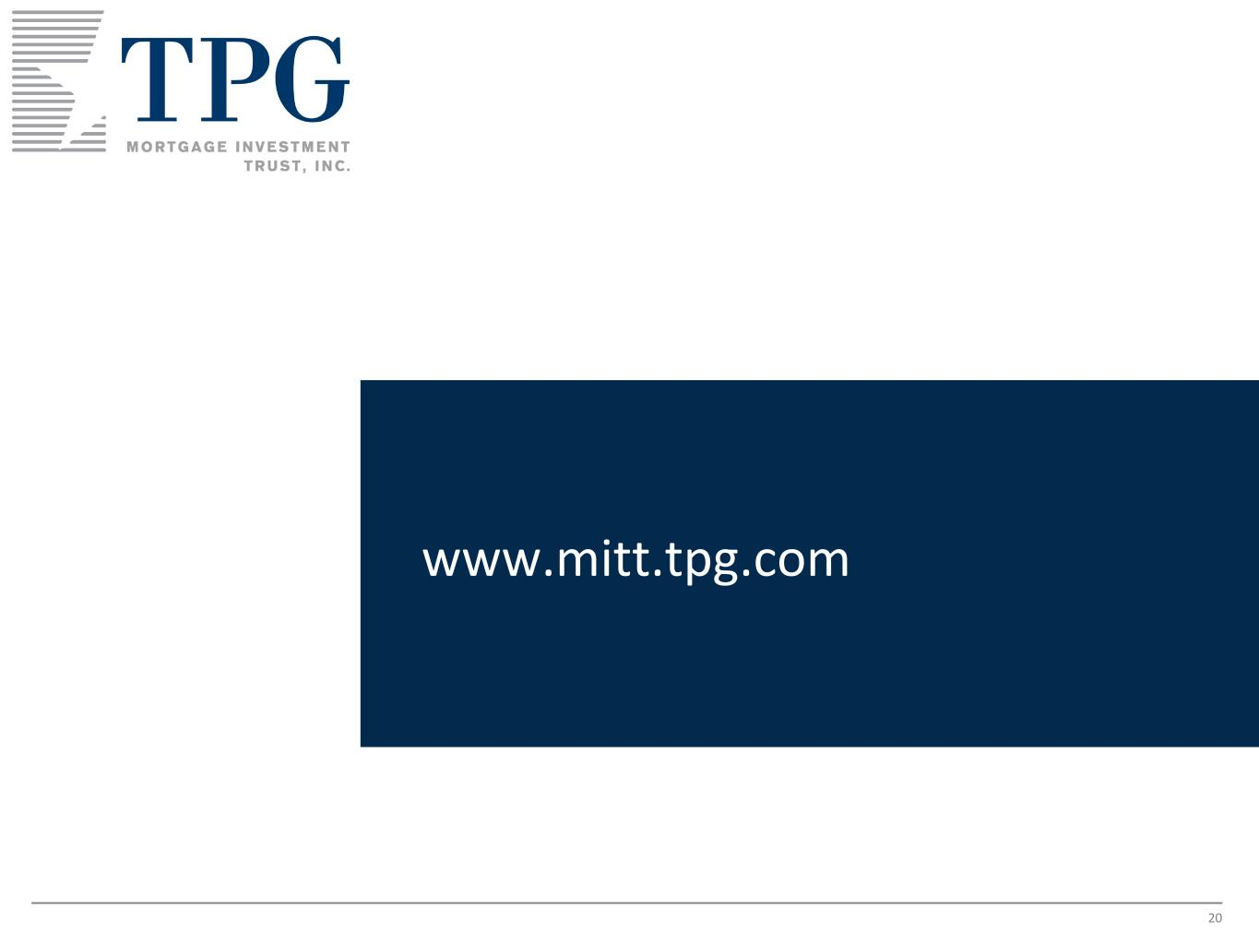
20 www.mitt.tpg.com

